

Laboratory Record

CSE3006 Computer Networks

B11+B12+B13, BL2026270100338,

Fall Semester :2026-2027

Name : Vinit Burkul
Registration No.: 24BAI10393
B.Tech Computer Science and Engineering Programme Output (POs):
- Engineering knowledge: Apply the knowledge of mathematics, science, engineering fundamentals, and an engineering specialization to the solution of complex engineering problems.
- Problem analysis: Identify, formulate, review research literature, and analyze complex engineering problems reaching substantiated conclusions using first principles of mathematics, natural sciences, and engineering sciences.
- Design/development of solutions: Design solutions for complex engineering problems and design system components or processes that meet the specified needs with appropriate consideration for the public health and safety, and the cultural, societal, and environmental considerations.
- Conduct investigations of complex problems: Use research-based knowledge and research methods including design of experiments, analysis and interpretation of data, and synthesis of the information to provide valid conclusions.
- Modern tool usage: Create, select, and apply appropriate techniques, resources, and modern engineering and IT tools including prediction and modeling to complex engineering activities with an understanding of the limitations.
- The engineer and society: Apply reasoning informed by the contextual knowledge to assess societal, health, safety, legal and cultural issues and the consequent responsibilities relevant to the professional engineering practice.
- Environment and sustainability: Understand the impact of the professional engineering solutions in societal and environmental contexts, and demonstrate the knowledge of, and need for sustainable development.
- Ethics: Apply ethical principles and commit to professional ethics and responsibilities and norms of the engineering practice.
- Individual and teamwork: Function effectively as an individual, and as a member or leader in diverse teams, and in multidisciplinary settings.
- Communication: Communicate effectively on complex engineering activities with the engineering community and with society at large, such as, being able to comprehend and write effective reports and design documentation, make effective presentations, and give and receive clear instructions.
- Project management and finance: Demonstrate knowledge and understanding of the engineering and management principles and apply these to one’s own work, as a member and leader in a team, to manage projects and in multidisciplinary environments.

- Life-long learning: Recognize the need for, and have the preparation and ability to engage in independent and life-long learning in the broadest context of technological change.

Index

Exp. No. | Date | Name of the Experiment | Page Number
1. | 25.07.202  6 | Study of Network Hardware & Functionalities  and Create a LAN Configuration using Hub and Switch
2. | 01.08.2026 | Configure Mesh, Ring, Bus, Star and Hybrid Topologies using Cisco Packet Tracer
3. | 01.08.2026 | Inter-LAN Communication using Router Configuration and Working of Repeaters and Bridges
4. | 25.08.2026 | Error Correcting Techniques using Hamming Code and Cyclic Redundancy Check
5. | 27.08.2026 | Implementation of Data Link Layer (DLL) Protocols -Stop and Wait ARQ, Go-Back-N ARQ and Selective Repeat ARQ
6. | 20.09.2026 | IPV6 Addressing using Cisco Packet Tracer.
7. | 20.09.2026 | ARP using Cisco Packet Tracer.
8. | 28.09.2026 | - To configure a wireless network using a wireless router and end devices in Cisco Packet Tracer.  - To implement an IoT setup in Cisco Packet Tracer.
9. | 28.09.2026 | Develop a TCP client-server program
10.
11.
12.

Exp No: 1 | Study of Network Hardware & Functionalities and Create a LAN Configuration using Hub and Switch
25.07.202
6

Aim:
  - To study various hardware components involved in the design and performance of networks, and to study various useful network commands.
  - To design and configure a LAN (Local Area Network) using a Switch and Hub.

Objective:
- Installing, and familiarising oneself with, Cisco Packet Tracer.
- Using different components of Cisco Packet Tracer, such as network devices, end devices, connectors, and so on.
- Building a simple network by connecting two End Devices with wires.
- Trying out various basic network commands, such as ‘color’, ‘ipconfig’, ‘ipconfig all’, ‘cls’, ‘nslookup’, ‘control c’, and ‘ping’, and learning their function(s).
- Creation of a Local Area Network while making use of a Switch and Hub.

Simulation Tool:
CISCO Packet Tracer

Theory:
Packet Tracer is a cross-platform visual simulation tool designed by Cisco Systems that allows users to create network topologies and imitate modern computer networks. The software allows users to simulate the configuration of Cisco routers and switches using a simulated command line interface. Packet Tracer makes use of a drag and drop user interface, allowing users to add and remove simulated network devices as they see fit.
Some important network devices are routers, switches, and hubs.
A router is a device that connects two or more packet-switched networks or subnetworks. It serves two primary functions: managing traffic between these networks by forwarding data packets to their intended IP addresses, and allowing multiple devices to use the same Internet connection.
A switch connects devices on a computer network by using packet switching to receive and forward data to the destination device. It learns the identities of connected devices and then only forwards data to the port connected to the device to which it is addressed.
A hub is a node that broadcasts data to every computer or Ethernet-based device connected to it. It is best suited for small, simple local area network (LAN) environments.

Color is an inbuilt command found inside the Windows Command Processor (cmd.exe), that is used for changing the colors for the console’s foreground and background.
IPCONFIG stands for Internet Protocol Configuration. This is a command-line application which displays all the current TCP/IP (Transmission Control Protocol/Internet Protocol) network configuration, and refreshes the DHCP (Dynamic Host Configuration Protocol) and DNS (Domain Name Server). It also displays IP address, subnet mask, and default gateway for all adapters. ‘ipconfig all’ shows even more detailed information about the same.
Cls is a command used to clear the screen, or console window, of commands executed prior, and their outputs.
Nslookup lets an Internet server administrator or any computer user enter a host name and find out the corresponding IP address or domain name system (DNS) record. The user can also enter a command for it to do a reverse DNS lookup and find the host name for an IP address that is specified.
Control C aborts the current task and allows the user to regain control. Ping’s most basic use is to confirm network connectivity between two hosts. It sends out an ICMP echo request to which it expects an ICMP echo reply response (ICMP stands for Internet Control Message Protocol).
LAN (Local Area Network):
LAN stands for local area network. A network is a group of two or more connected computers, and a LAN is a network contained within a small geographic area, usually within the same building. Home WiFi networks and small business networks are common examples of LANs.
The simplest Internet-connected LANs require only a router and a way for computing devices to connect to the router, such as via Ethernet cables or a WiFi hotspot. LANs without an Internet connection need a switch for exchanging data. Large LANs, such as those in a large office building, may need additional routers or switches to more efficiently forward data to the right devices.
A switch is a networking device that connects devices in a network and uses packet switching to send, receive or forward data packets or data frames over the network. A switch has many ports, to which computers are plugged in. When a data frame arrives at any port of a network switch, it examines the destination address, performs necessary checks and sends the frame to the corresponding device(s). It supports unicast, multicast as well as broadcast communications.
A network hub is a node that broadcasts data to every computer or Ethernet-based device connected to it. A hub is less sophisticated than a switch, the latter of which can isolate data transmissions to specific devices.

Network hubs are best suited for small, simple local area network (LAN) environments. Hubs cannot provide routing capabilities or other advanced network services. Because they operate by forwarding packets across all ports indiscriminately, network hubs are sometimes referred to as "dumb switches."

Procedure:
- Installation of CISCO Packet Tracer and study exercise:
  - First, look up “Cisco Packet Tracer” or similar, on your search engine of choice.
  - You should find a webpage on the Cisco Networking Academy site. Click on that, then click on “View Courses”.
  - You should now have been redirected to the Skills For All website. Find the “Getting Started with Cisco Packet Tracer” course, and click on “Get Started”.
  - Log in with any account of your choice.
  - You should now be able to access the course material. On one of the first few pages, you should be able to find a link that redirects you to a Resources page.
  - From here, you can download (and, subsequently, install) the right version.
  - After looking through all of the various menus and options, trying out a few devices, testing how connections work etc. Select any two End Devices of your choice, and move them onto the main area.
  - Select a switch, and a server, and move them to the main area as well.
  - Connect them with wires as appropriate (there is an option titled “Automatically Choose Connection type” which picks the right one for you).
  - A network with two end devices has now been created!
  - For the next task, open up the Command Prompt.
  - Type in the aforementioned commands one by one, and take screenshots of their outputs, if any.

Create a LAN Configuration using a Switch and Hub
  - Startup Cisco Packet Tracer, and place any 4 end devices of your choice.
  - Connect them all using a switch/ Hub.
  - For each of them: double-click the device, go to the Desktop tab, click on IP Configuration and set an IP.
  - Make sure to give them all similar IPs – for eg, if an address is p.q.r.s, keep the ‘p’, ‘q’, and ‘r’ values ( 1 to 254) equal for all 4 end devices.
  - In one of the toolbars, on the top left, click on ‘Add Simple PDU’.
  - Select one of the devices to be the sender of the message, and another to be the recipient.
  - Click on ‘Simulation’ in the bottom right, and start the simulation of the Scenario.
  - Take screenshots as and when necessary, throughout the duration of the simulation.

Output: (Simulation Screen Shots)
- Cisco Packet Tracer main window
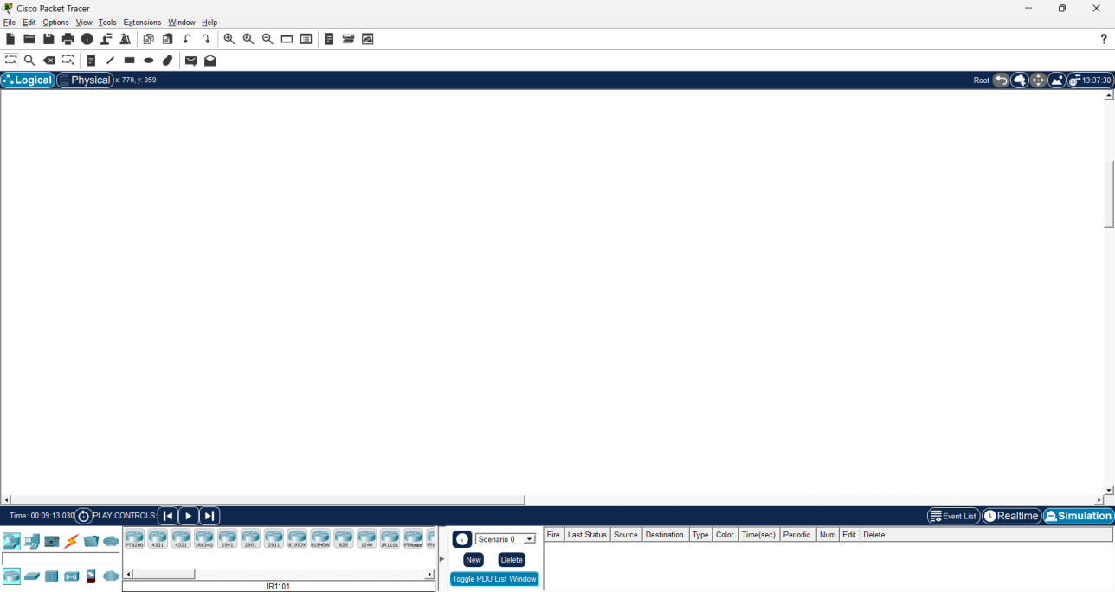

- 2 PCs + Switch + Server topology

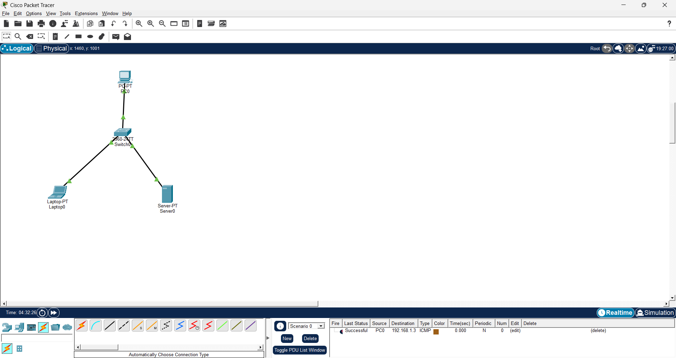

- Color-ipconfig:

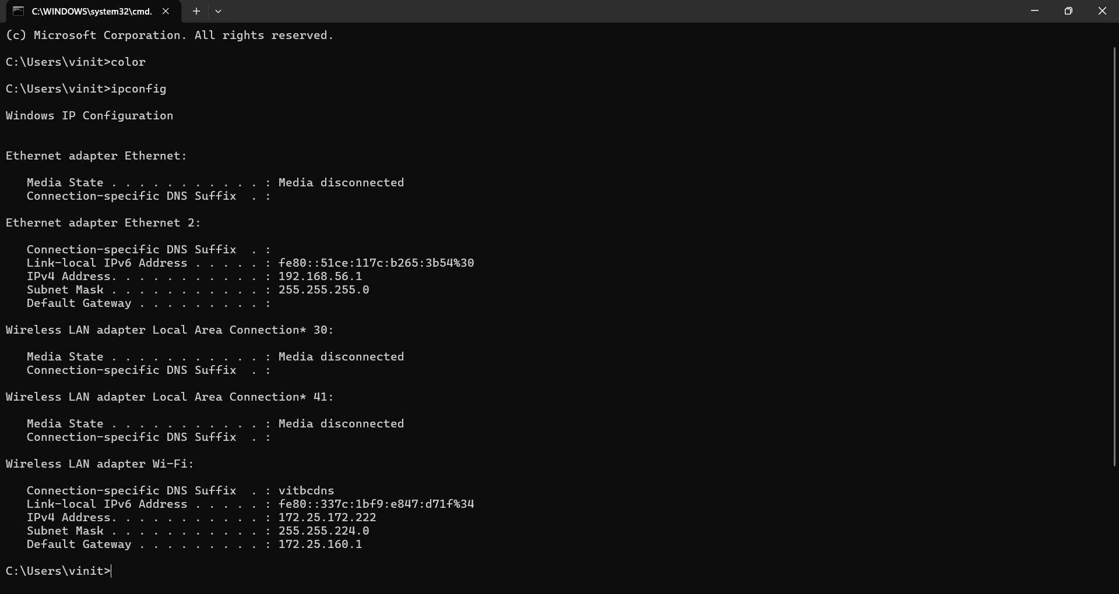

- ipconfig /all:

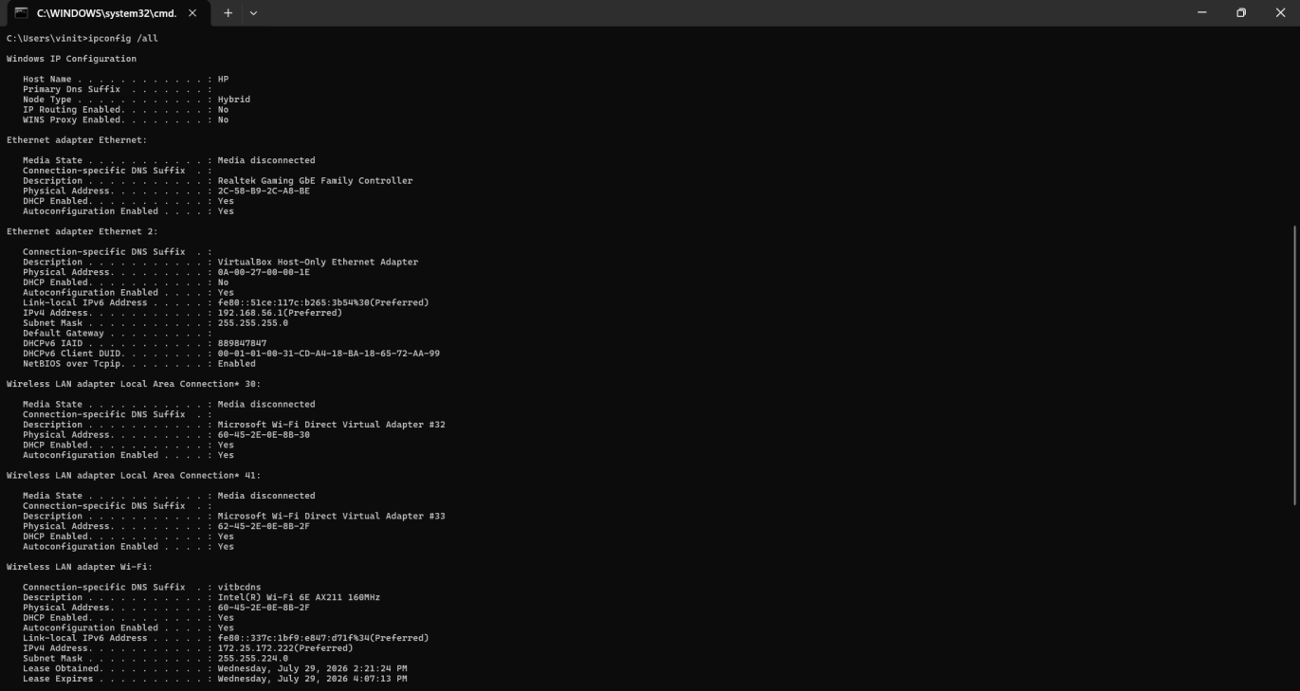
- cls:

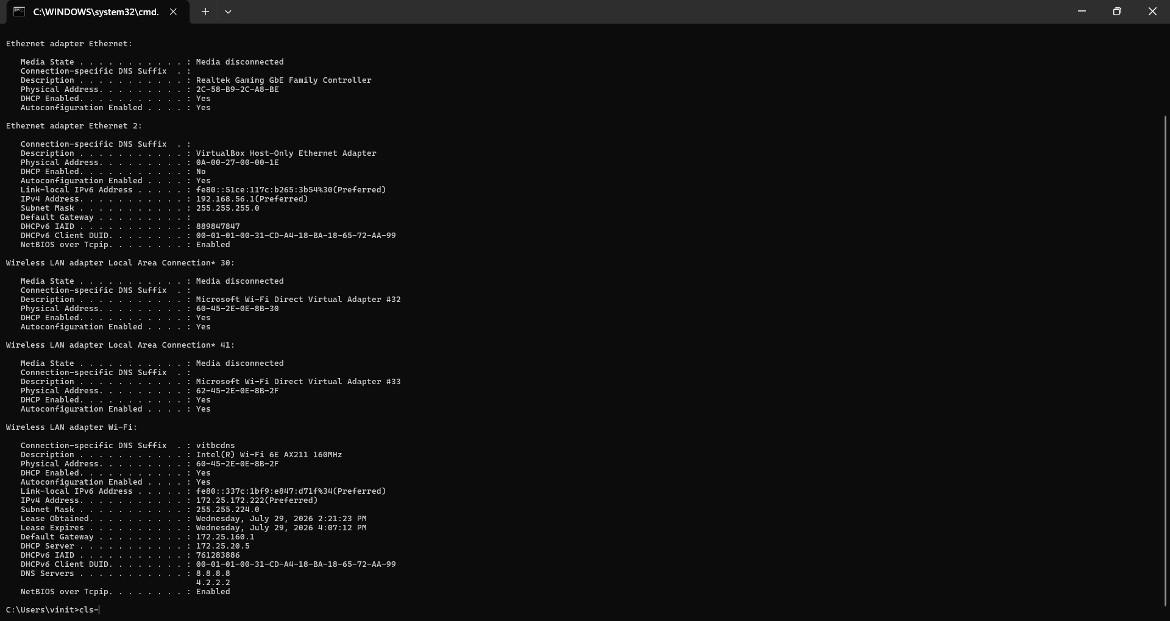

- nslookup google.com:

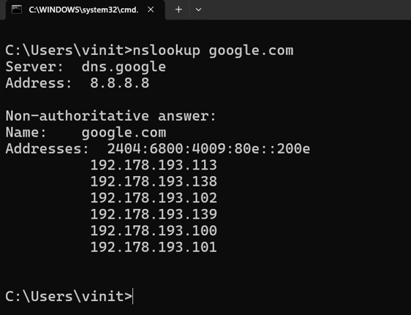

- ping -t google.com and Ctrl + C:

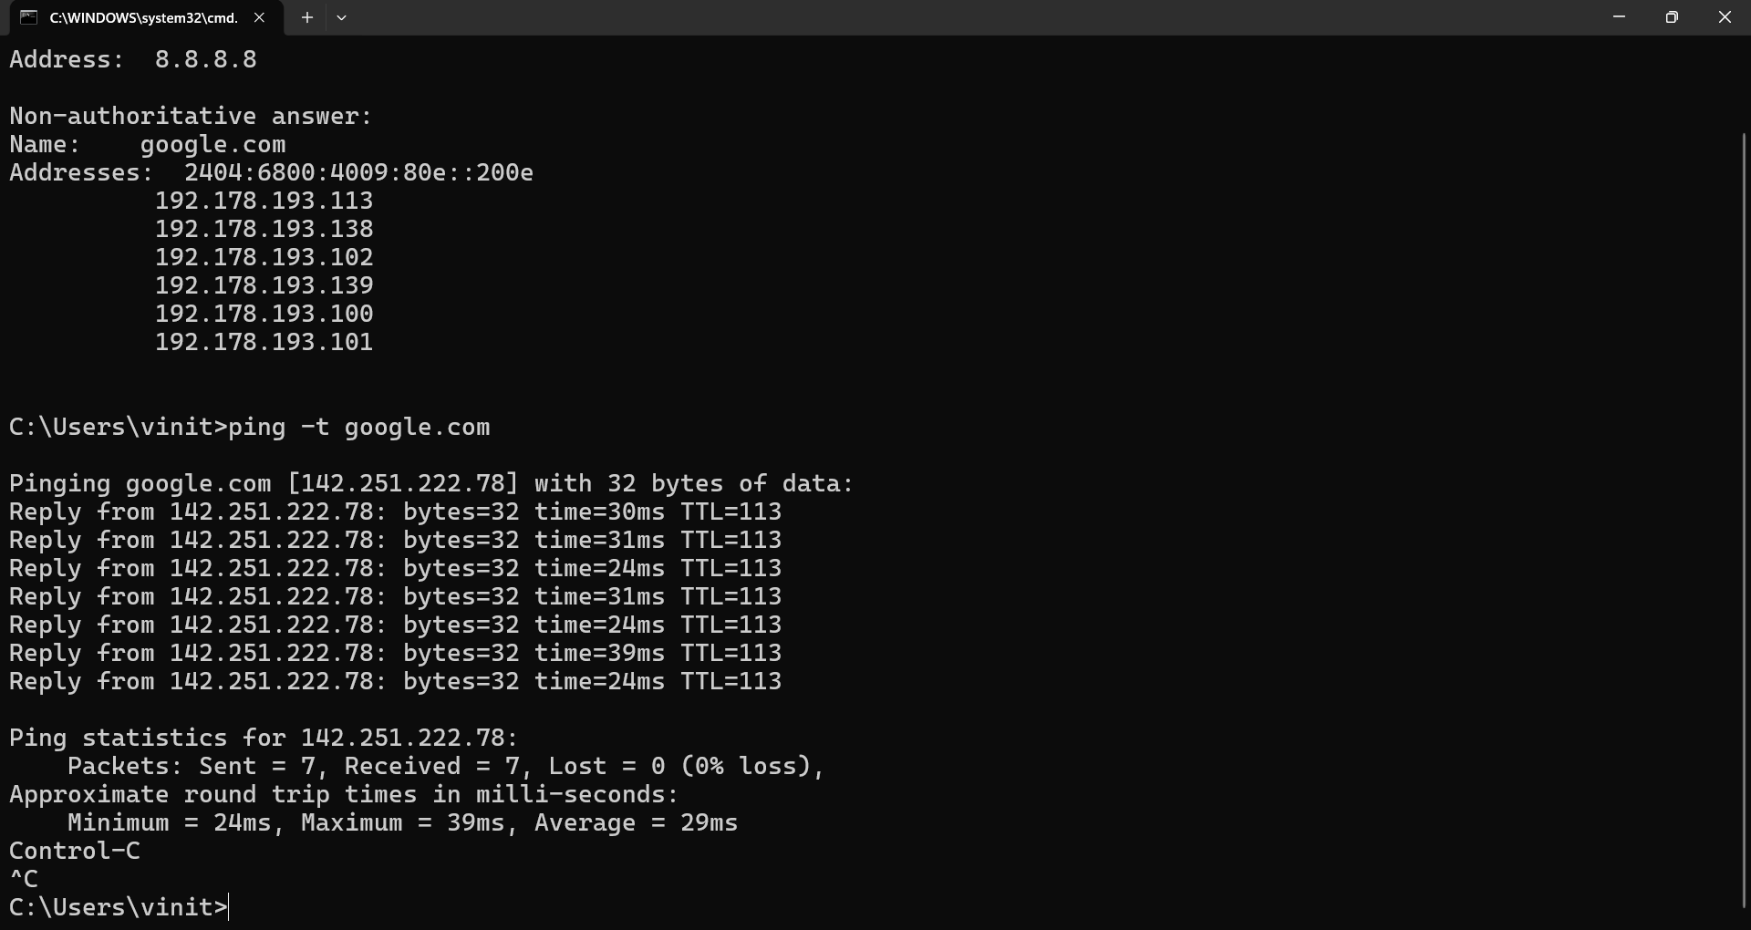

- ping google.com:

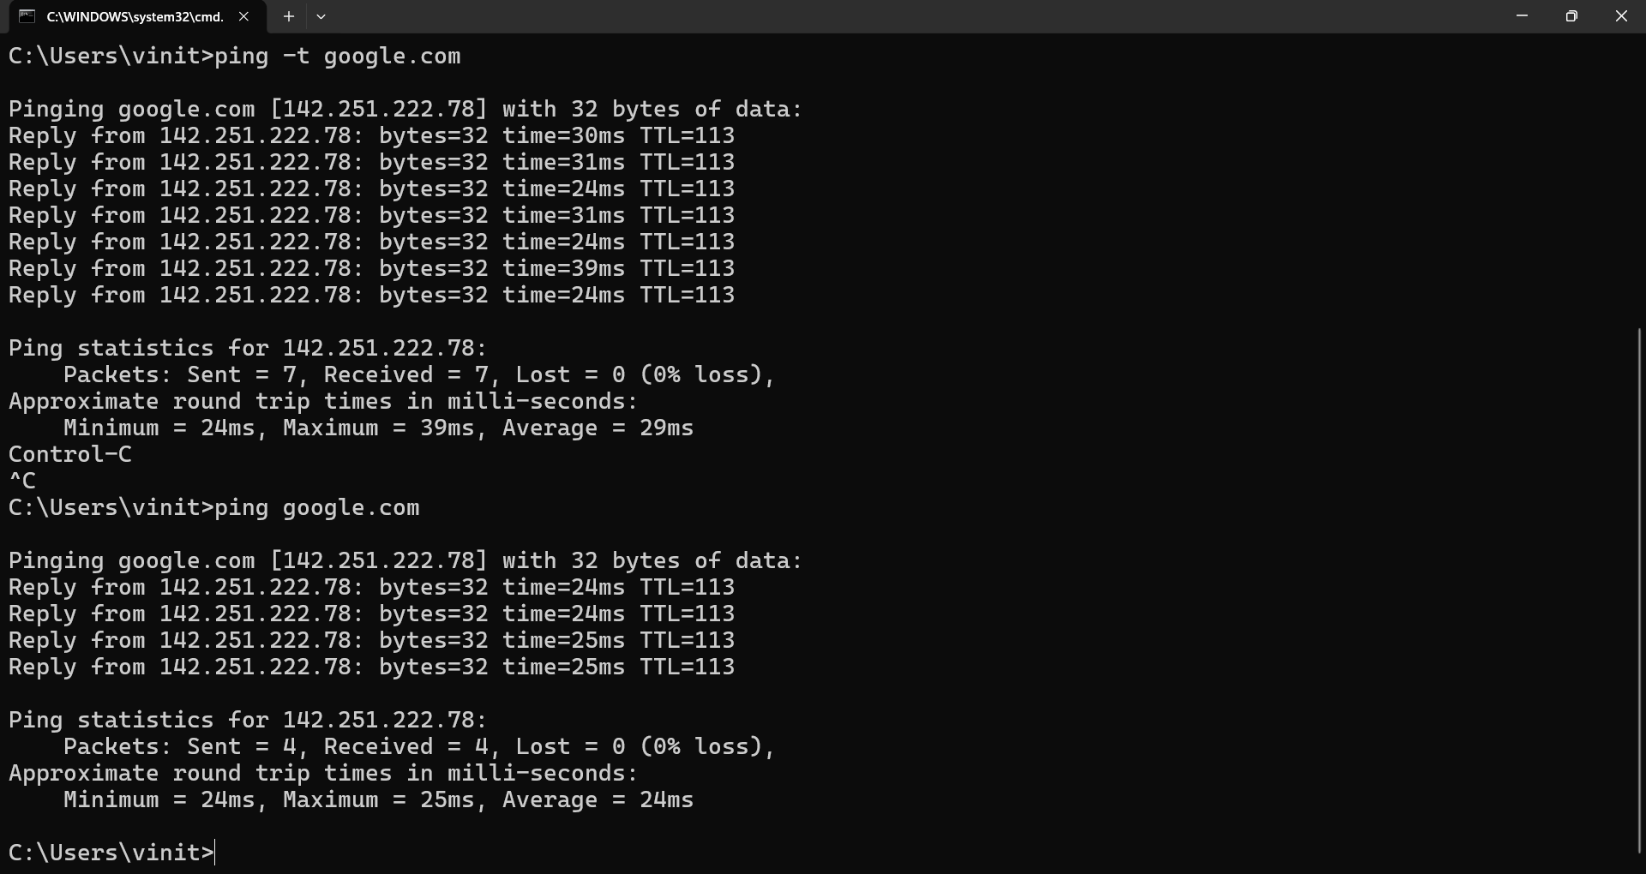

- 4-PC LAN topology:

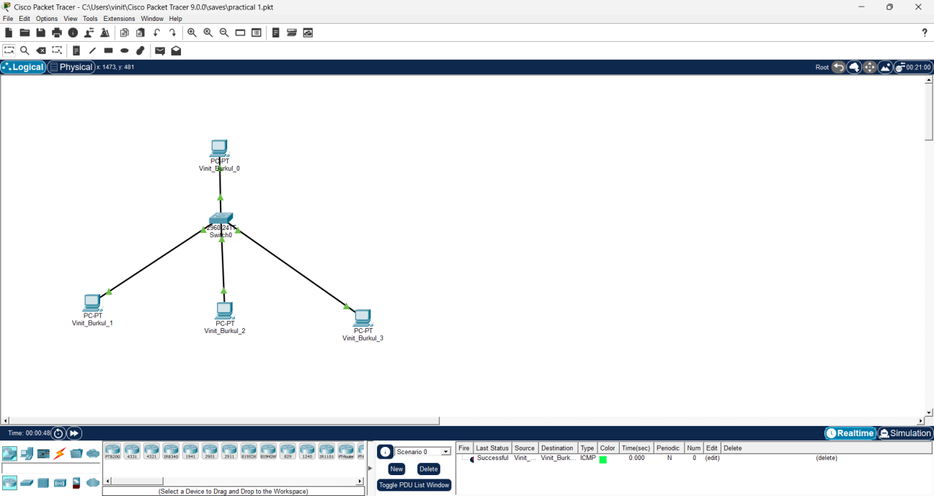

- IP Configuration:

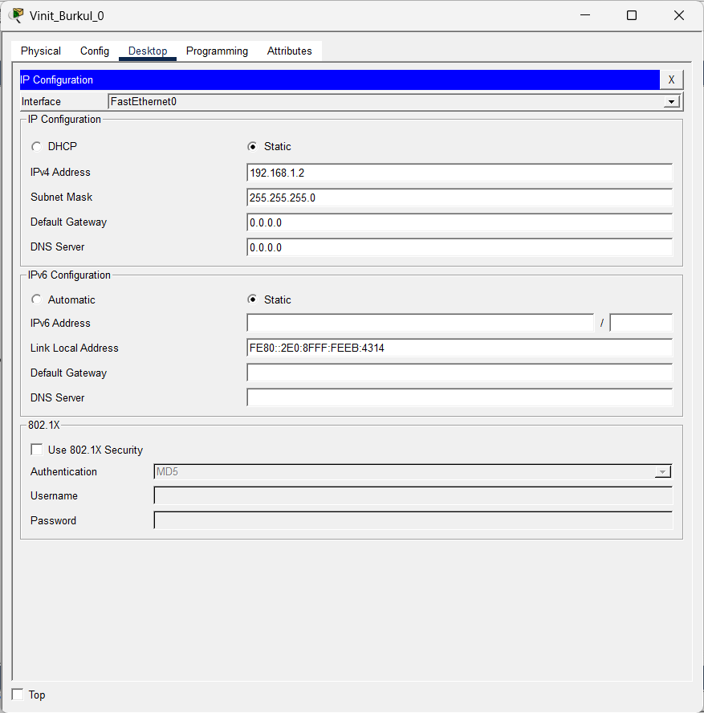

- Pinging over IP address from one PC to another:
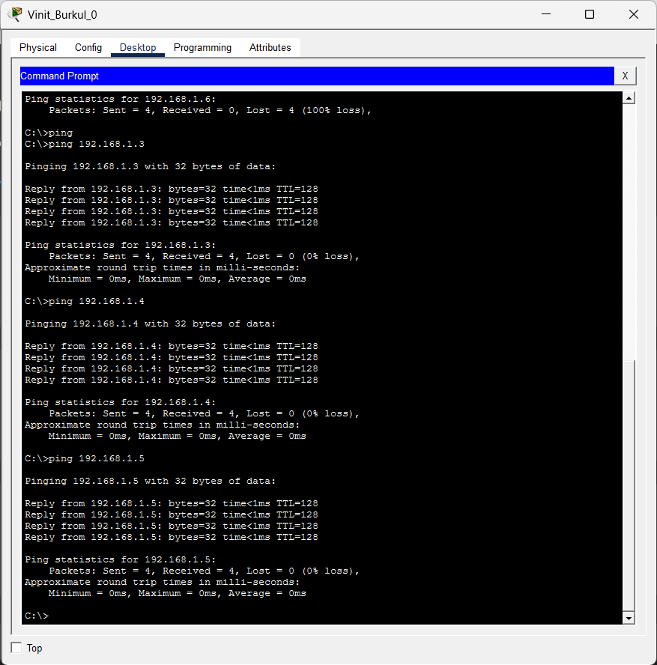

- Simulation Mode (packet in transit):

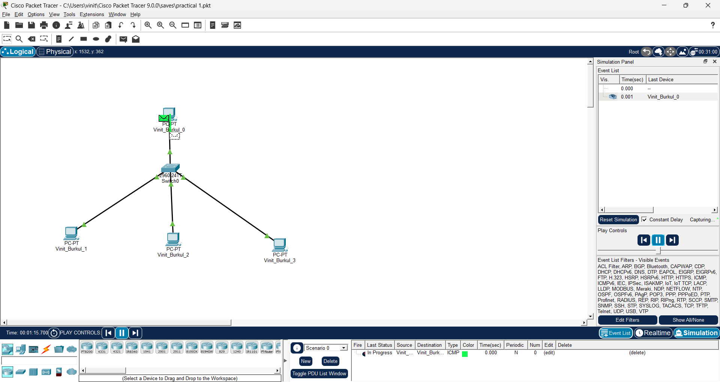

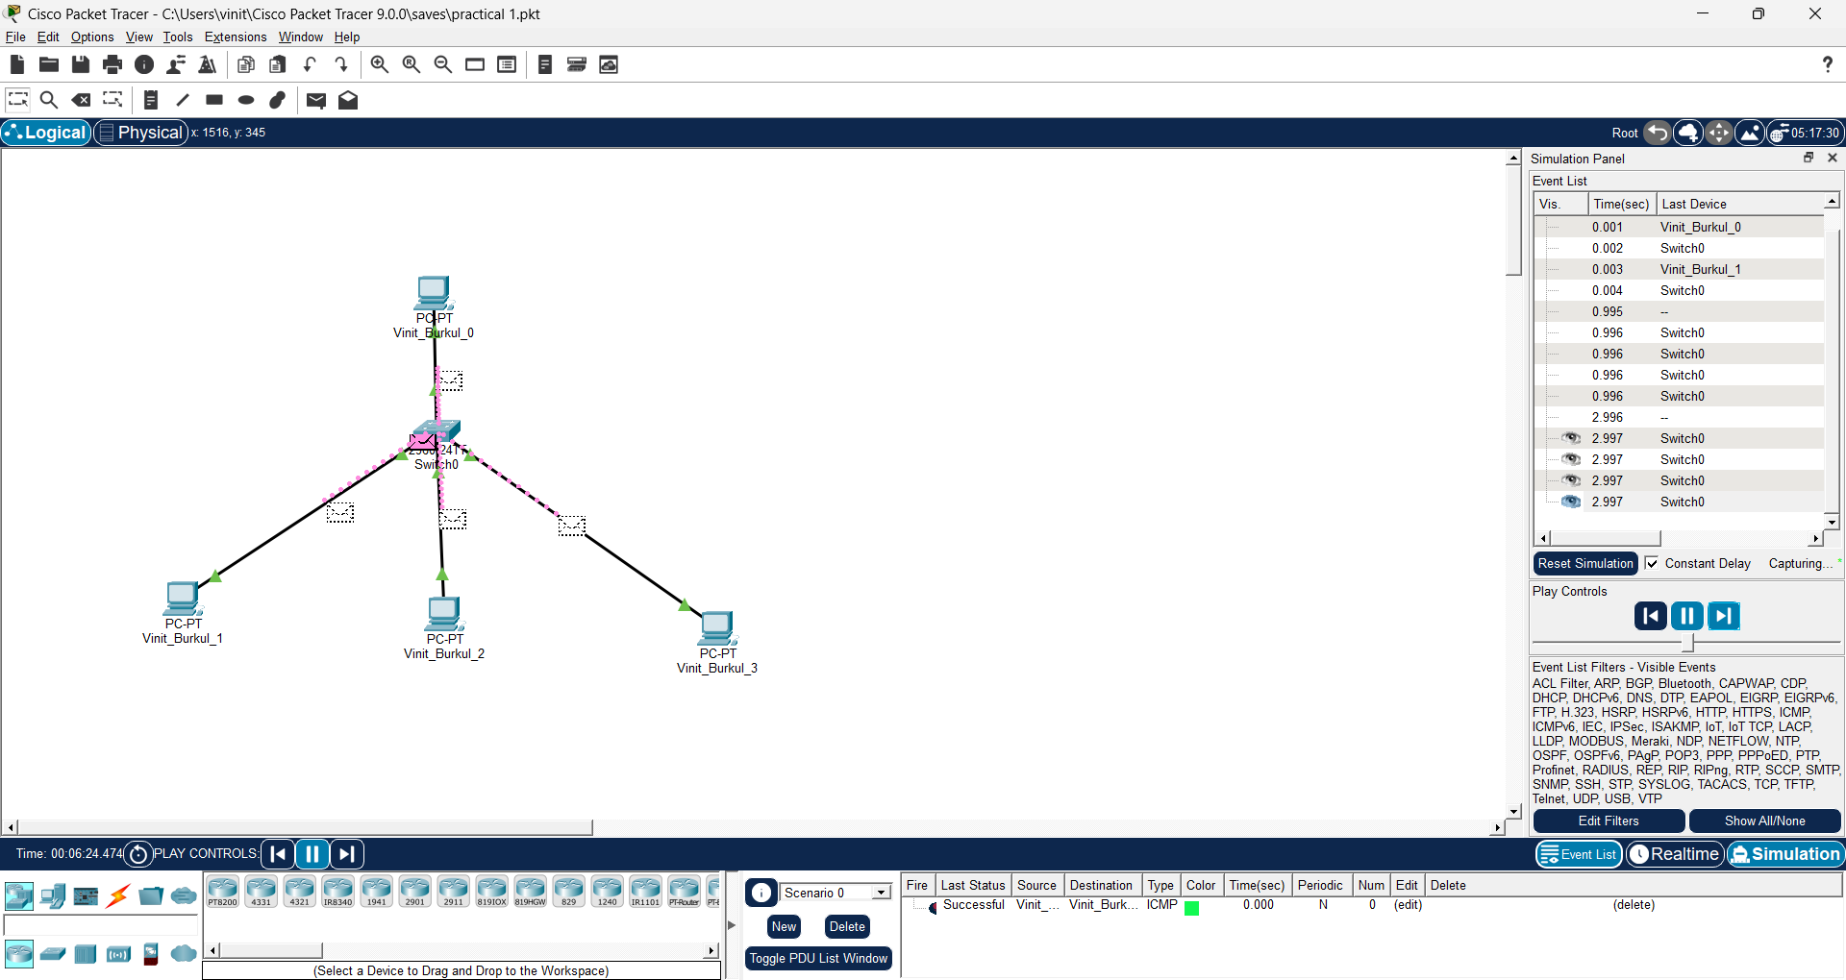

Result:
- The function of various commands (some network-related, some general purpose) in the Command Prompt is executed and learnt about Cisco Packet Tracer, and how to simulate basic networks.
- A simple LAN network using a switch and Hub is created and executed in cisco packet tracer.
References:
- https://www.netacad.com/courses/packet-tracer
- https://skillsforall.com/course/getting-started-cisco-packet-tracer
- https://www.cloudflare.com/learning/network-layer/what-is-a-lan/
- https://www.tutorialspoint.com/what-are-switches-in-computer-network

Exp No: 2 | Configure Mesh, Ring, Bus, Star and Hybrid Topologies using Cisco Packet Tracer
1.08.2026

Aim:
To configure and simulate Mesh, Ring, Bus, Star, and Hybrid network topologies using Cisco Packet Tracer and analyze their communication characteristics.

Objectives:
- To create different network topologies in Cisco Packet Tracer.
- To configure IP addresses for all network devices.
- To simulate data transmission in each topology.
- To compare the behavior and communication of different network topologies.

Simulation Tool:

Cisco Packet Tracer

Theory:
A network topology defines the physical or logical arrangement of devices in a network. Different topologies are used depending on network size, cost, reliability, and performance requirements.
- Bus Topology: All devices are connected to a single communication cable called the bus. Data travels along the cable, making it simple and inexpensive, but failure of the main cable can disrupt the entire network.
- Star Topology: Every device is connected to a central hub or switch. It is easy to install, manage, and troubleshoot. Failure of one cable affects only one device, but failure of the central device affects the entire network.
- Ring Topology: Devices are connected in a circular path where data travels around the ring. It provides orderly communication but can be affected if one connection fails.
- Mesh Topology: Every device is connected directly to every other device. It offers high reliability and fault tolerance but requires more cables and higher installation cost.
- Hybrid Topology: A combination of two or more network topologies. It provides flexibility, scalability, and improved performance by combining the advantages of different topologies.
Each topology has its own advantages and limitations regarding scalability, fault tolerance, maintenance, and cost. The choice depends on the requirements of the network.

Output: (Simulation Screen Shots)
- STAR Topology:
Basic structure:
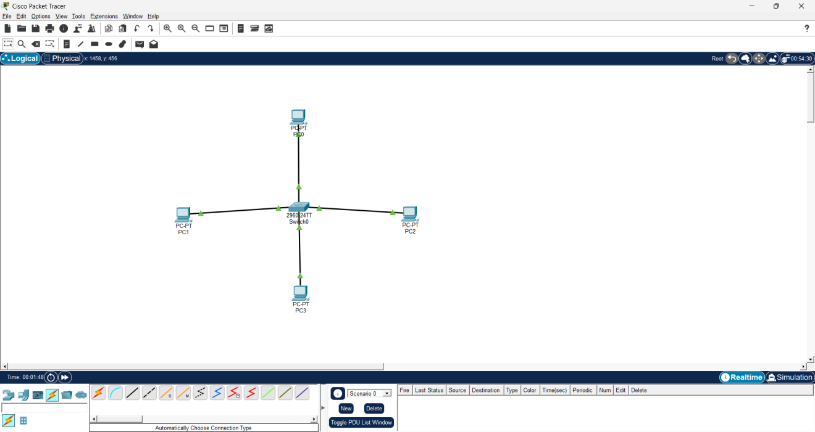
IP Congifuration:
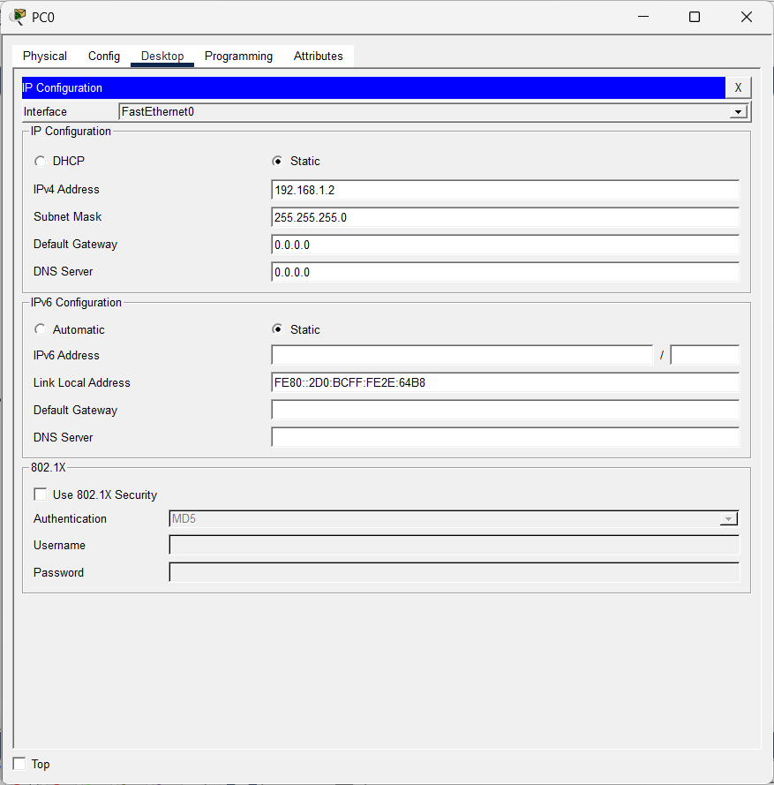
PING Status:
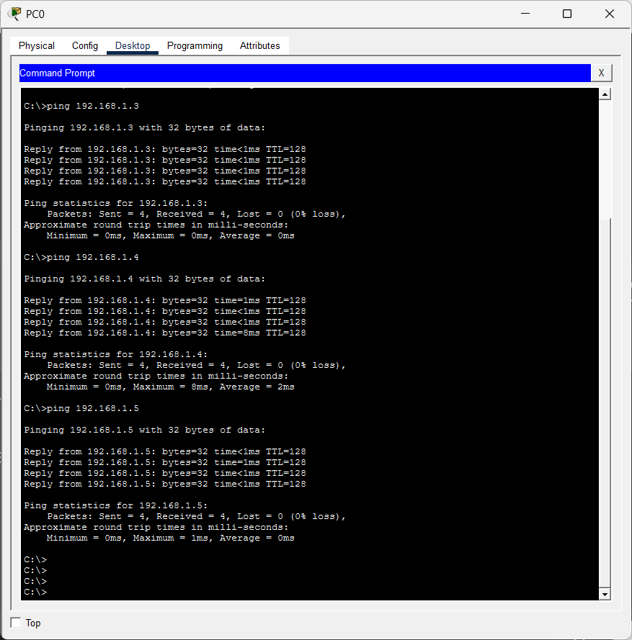
Simulation:
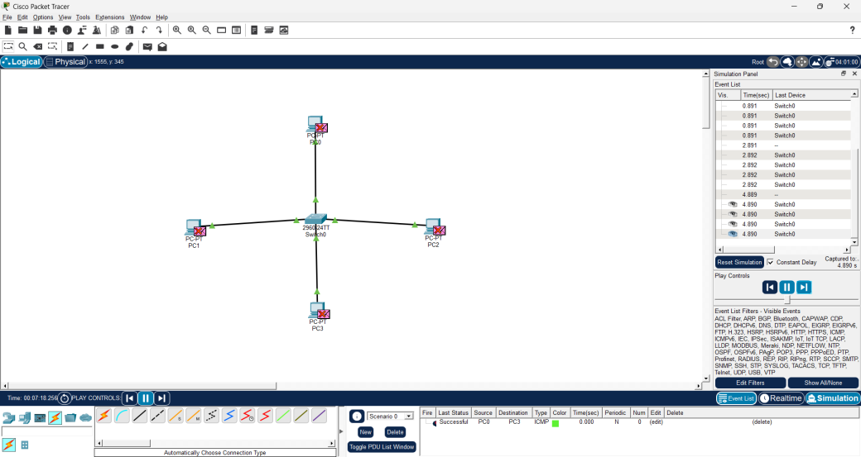

- BUS Topology:
Basic Structure:
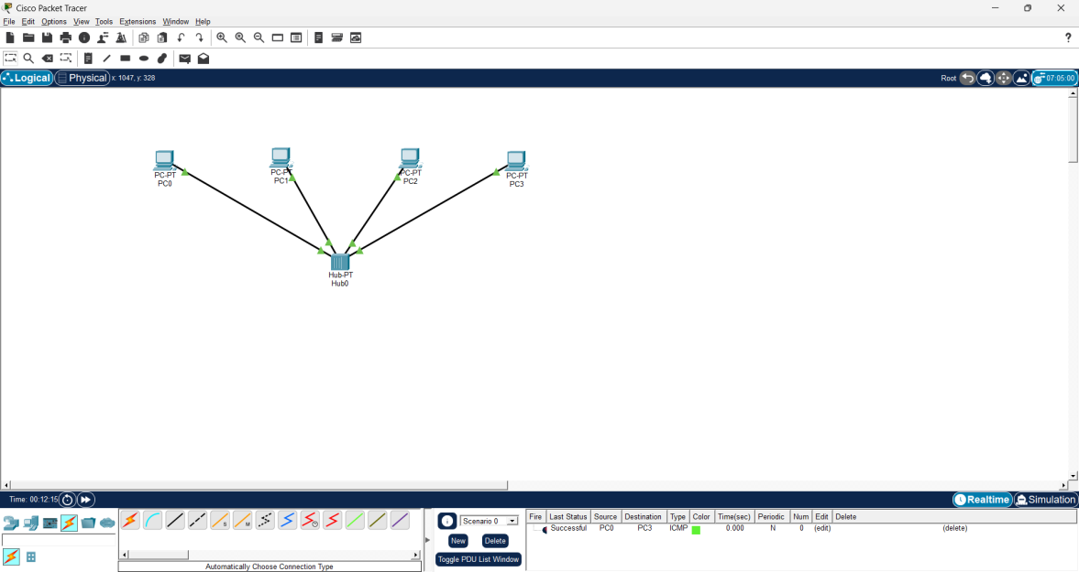
IP Configuration:
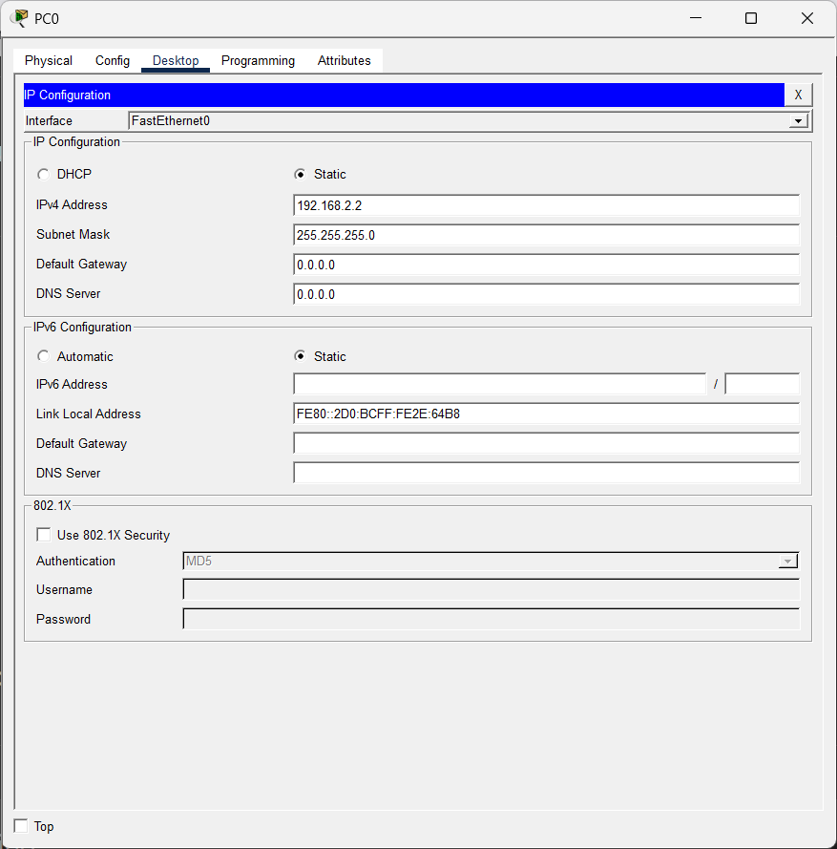

Ping Status:
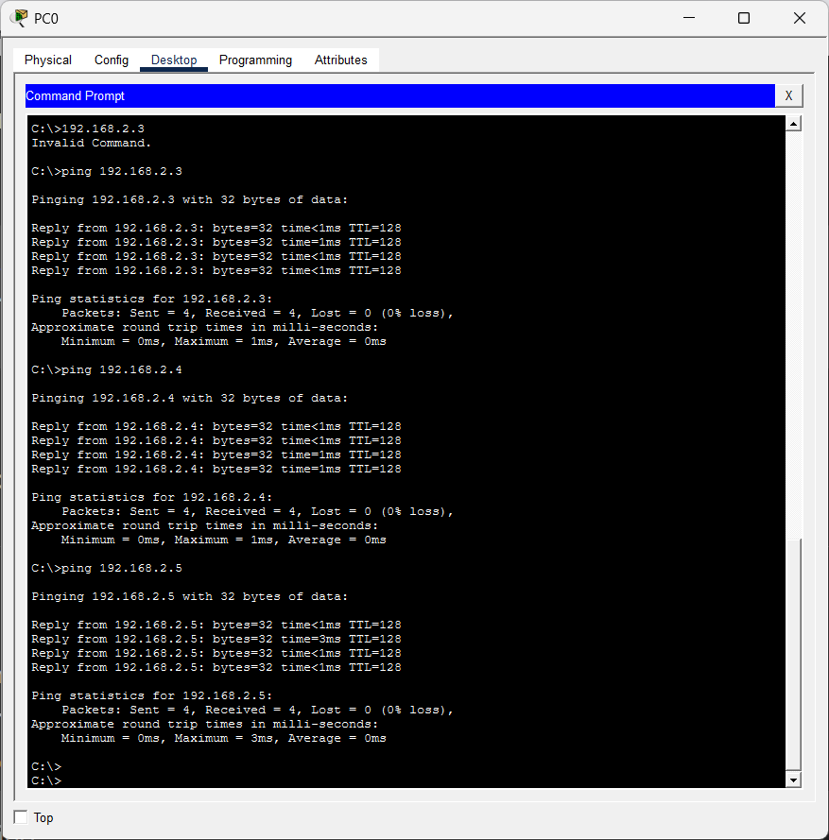
Simulation:
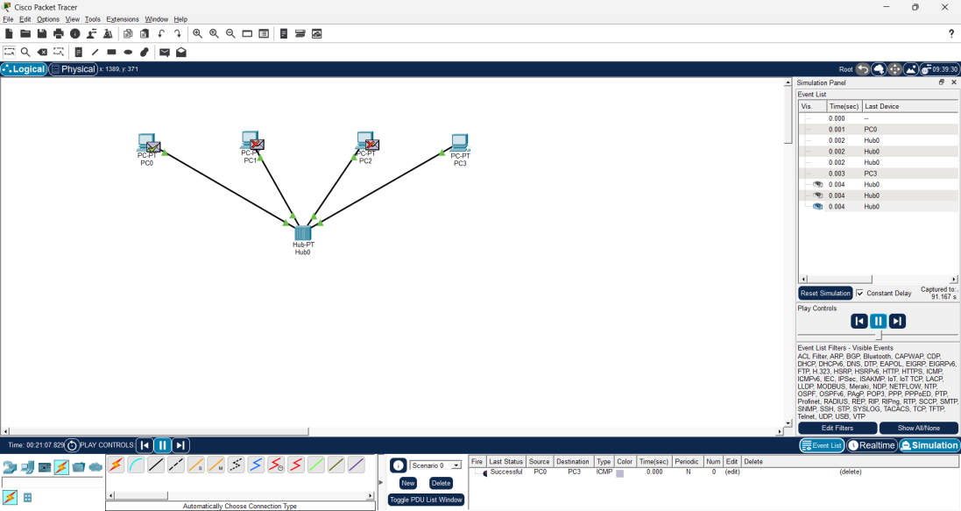

Ring Topology:
Basic structure:
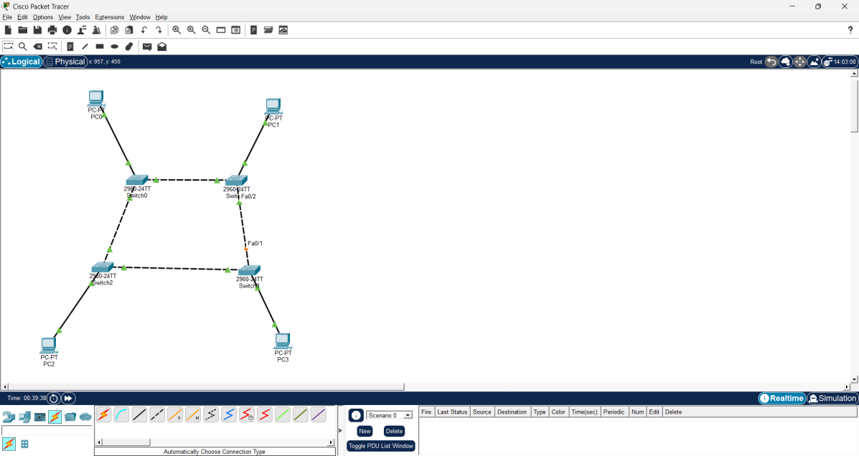
IP Configuration:
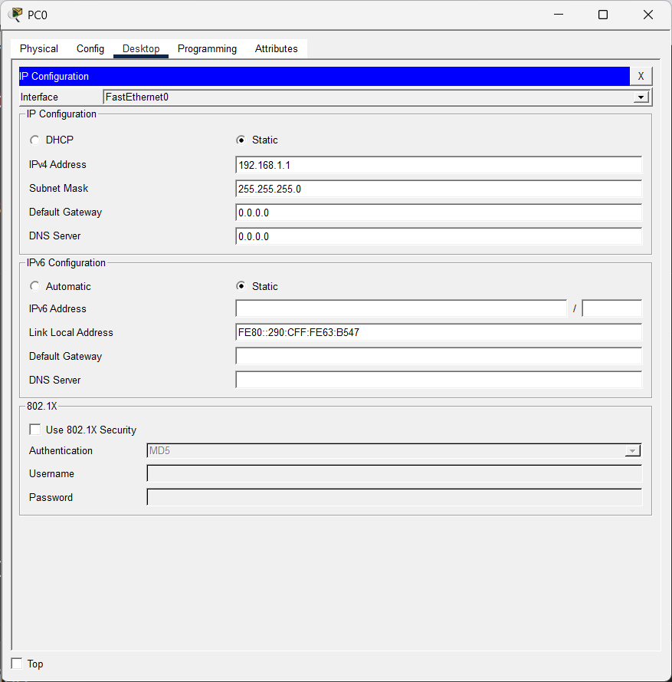
Ping Status:
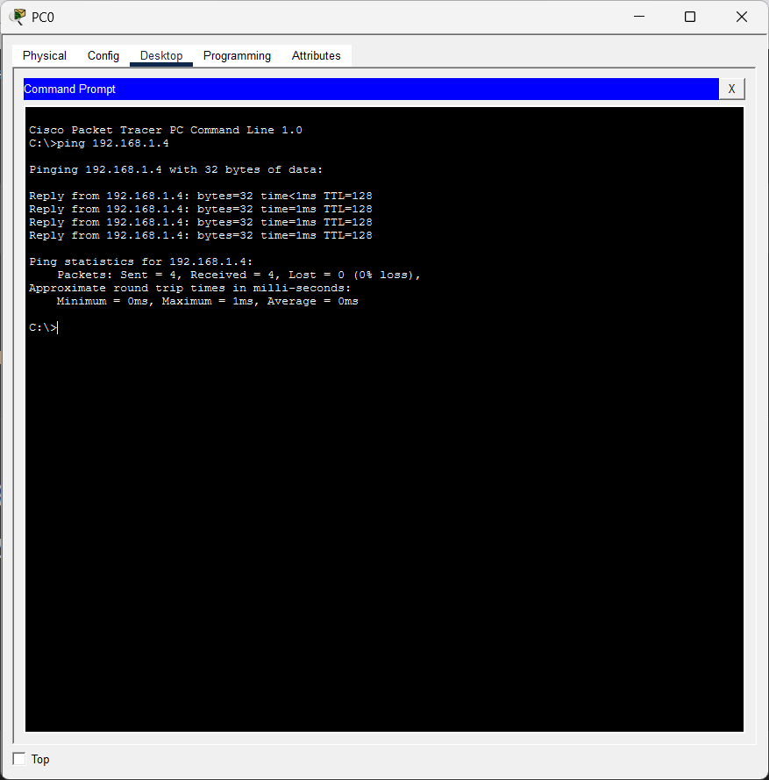
Simulation:
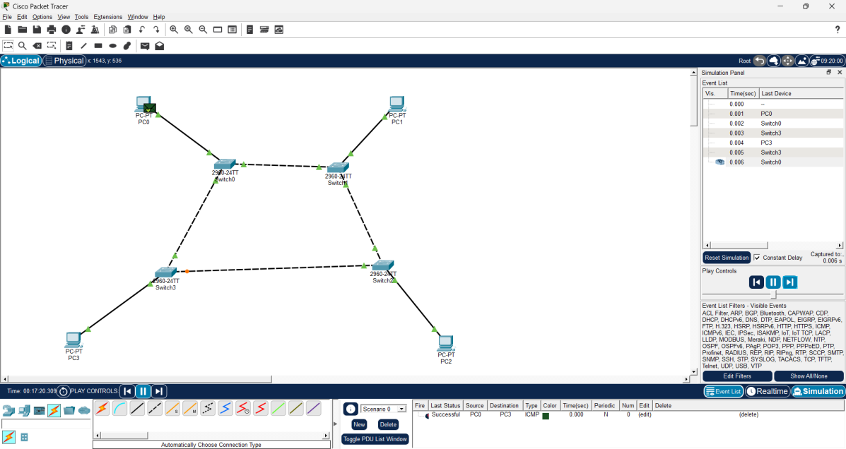

Mesh Topology:
Basic structure:
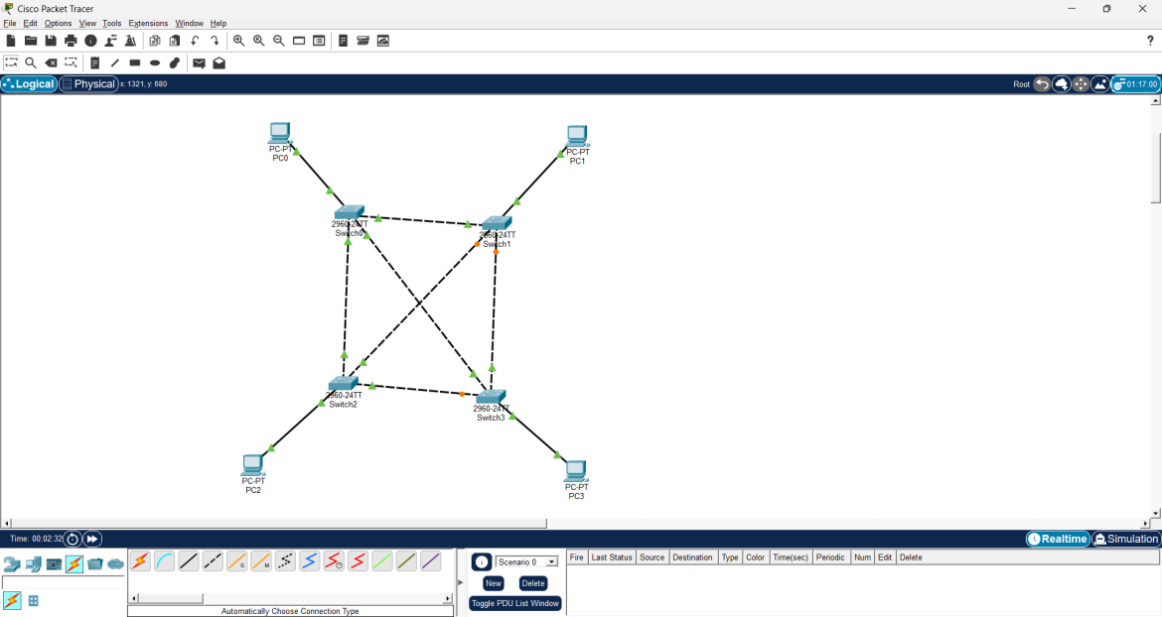
IP Configuration:
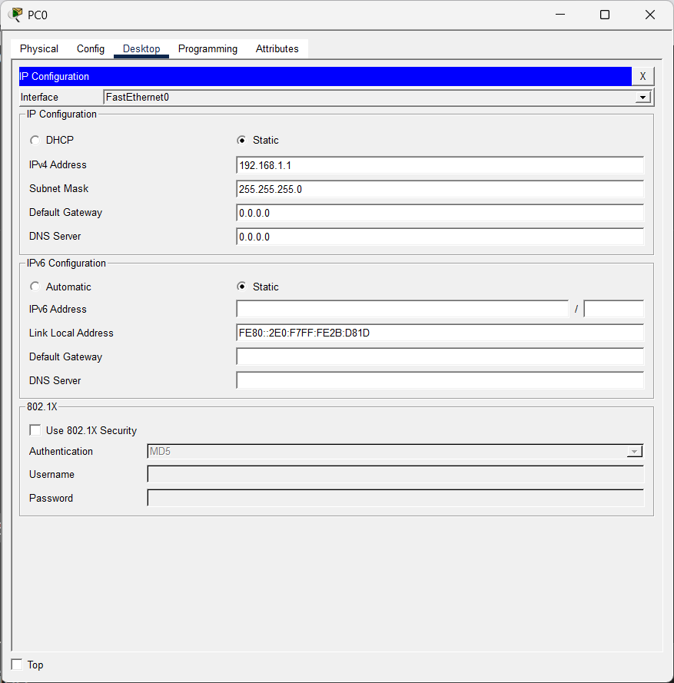
Simulation:
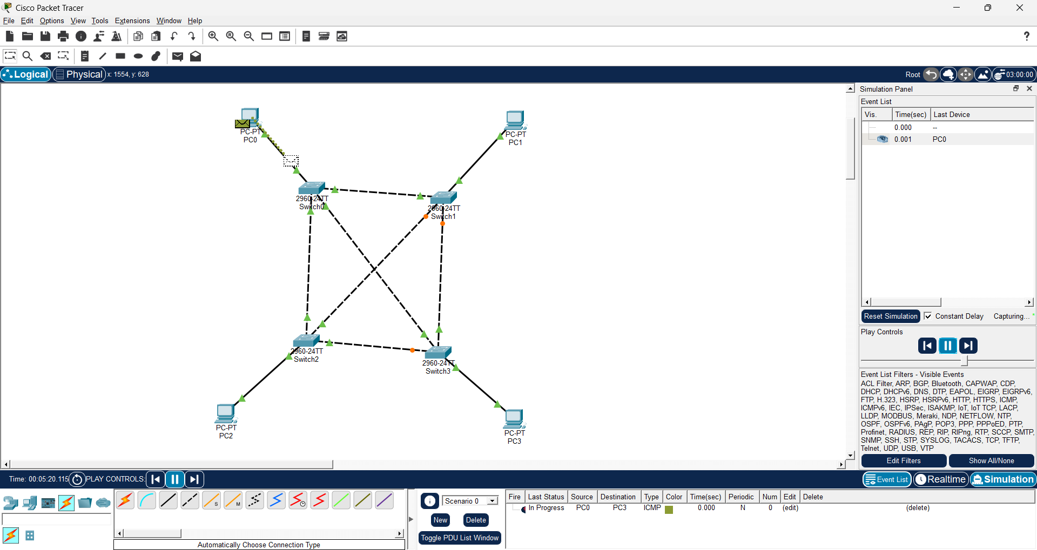
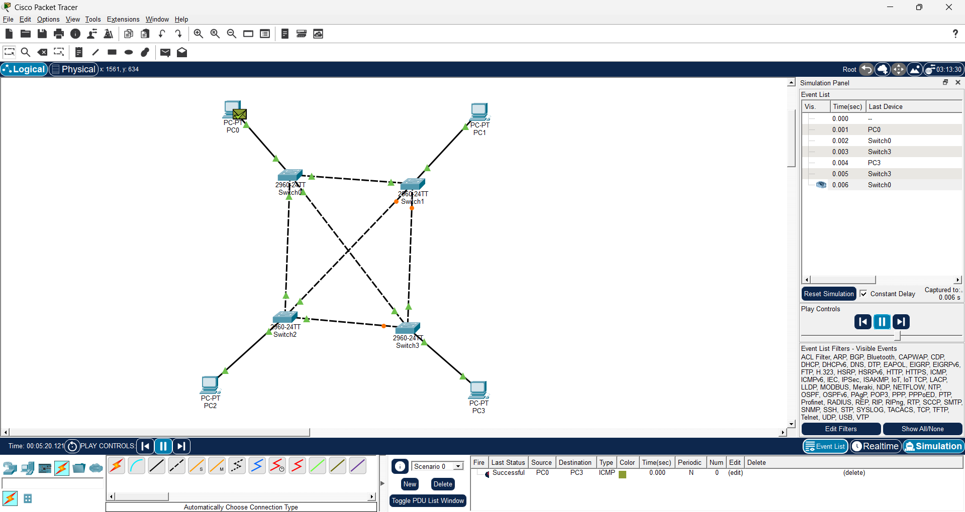

Hybrid Topology:
Basic Structure:
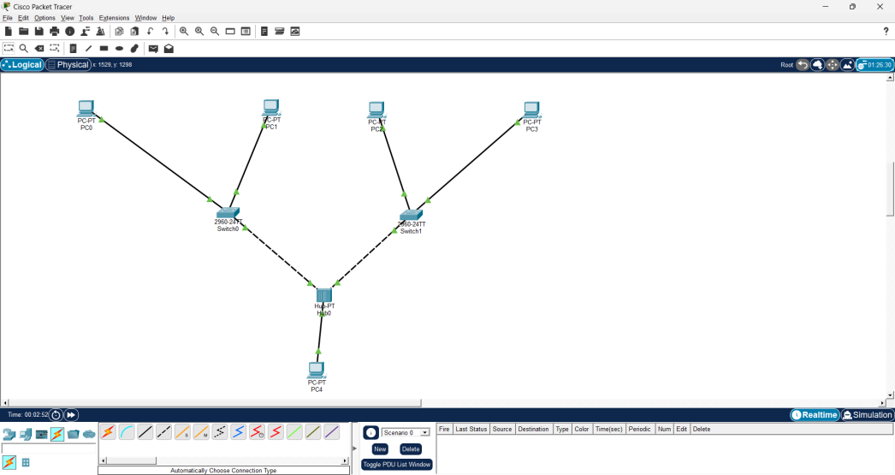
IP configuration:
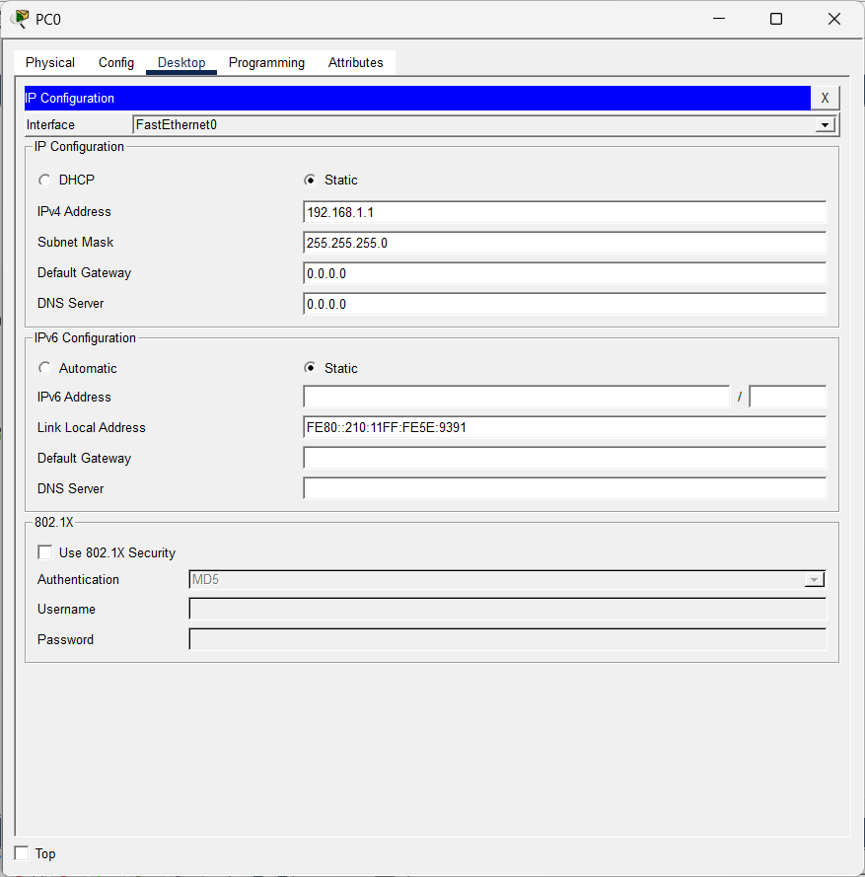

Ping Status:
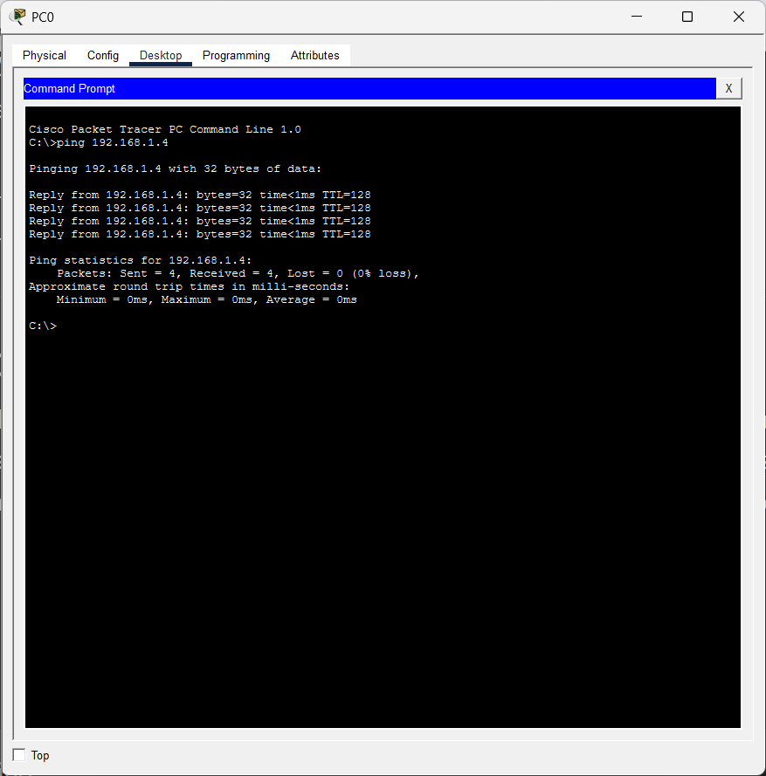
Simulation:
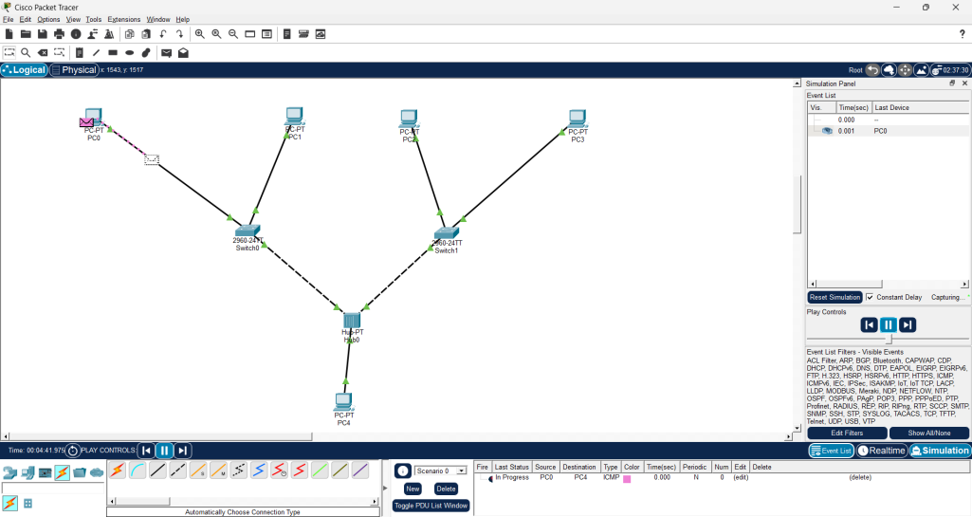

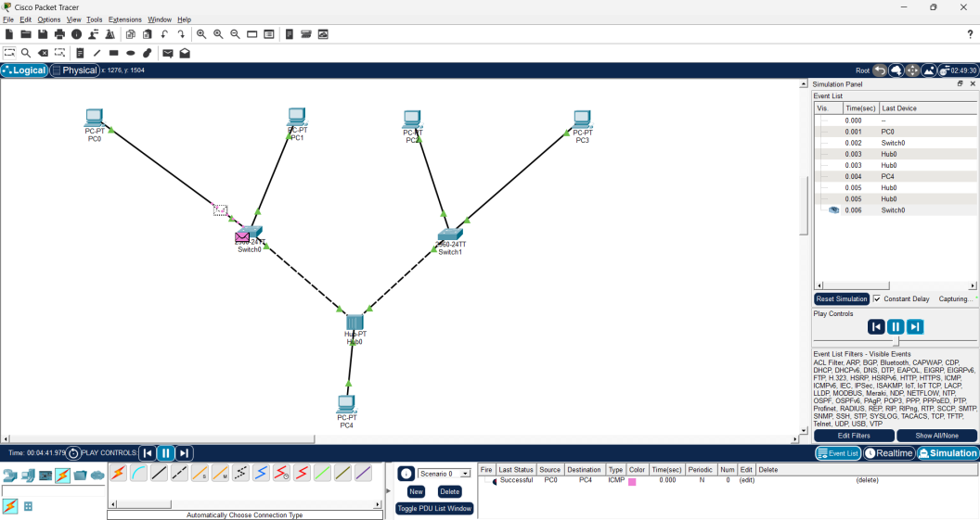
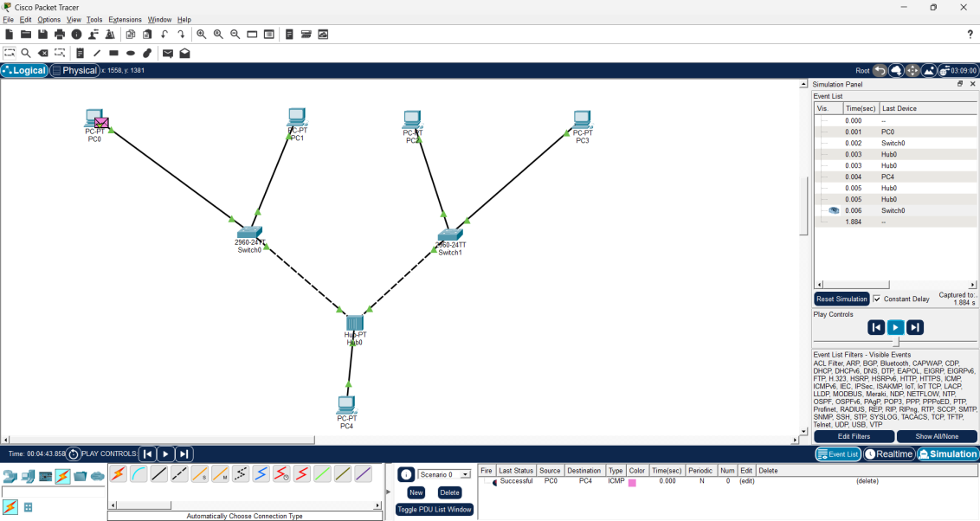

Result
Successfully configured inter-LAN communication using a router and verified communication between different LANs. The working of repeaters and bridges was also demonstrated successfully using Cisco Packet Tracer, confirming proper signal transmission and network segmentation.
References:
  - https://www.netacad.com/courses/packet-tracer
  - https://skillsforall.com/course/getting-started-cisco-packet-tracer
  - https://www.cloudflare.com/learning/network-layer/what-is-a-lan/

Exp No: 3 | Inter-LAN Communication using Router Configuration and Working of Repeaters and Bridges
1.08.2026

Aim:
- To connect two Local Area Networks (LANs) and enable communication between them using a router.
- To demonstrate the working of repeaters and bridges using Cisco Packet Tracer.

Objectives
- To configure a router for communication between two different LANs.
- To assign IP addresses and default gateways to all network devices.
- To understand the routing process between different networks.
- To study the working principle and applications of repeaters and bridges.
- To verify successful communication using simulation in Cisco Packet Tracer.

Simulation Tool:
- Cisco Packet Tracer

Theory:
A router is a Layer-3 networking device that connects two or more different networks and forwards data packets between them based on IP addresses. It examines the destination IP address of each packet and uses its routing table to determine the best path for forwarding the packet. Routers enable communication between different LANs and WANs while efficiently managing network traffic.
A repeater is a physical layer device that regenerates and amplifies weak or degraded signals before retransmitting them. It is mainly used to extend the communication distance of a network without changing the data being transmitted.
A bridge is a data link layer (Layer-2) device that connects two or more LAN segments. It filters and forwards frames using MAC addresses, reducing unnecessary network traffic and improving network performance.
In this practical, two separate LANs are connected through a router to establish inter-LAN communication. The working of repeaters and bridges is also demonstrated to understand their role in extending network coverage and connecting network segments efficiently.

Output:
- Repeater:
Basic Structure:
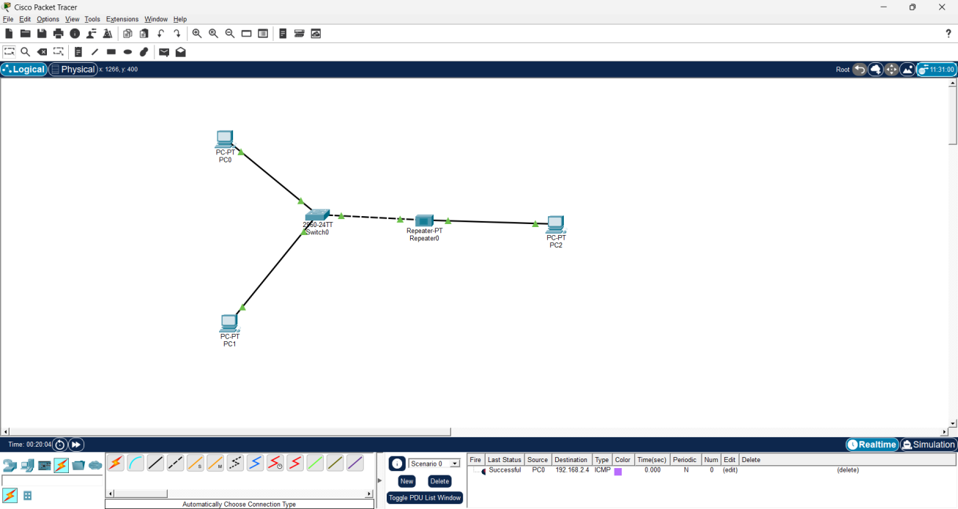
IP Configuration:
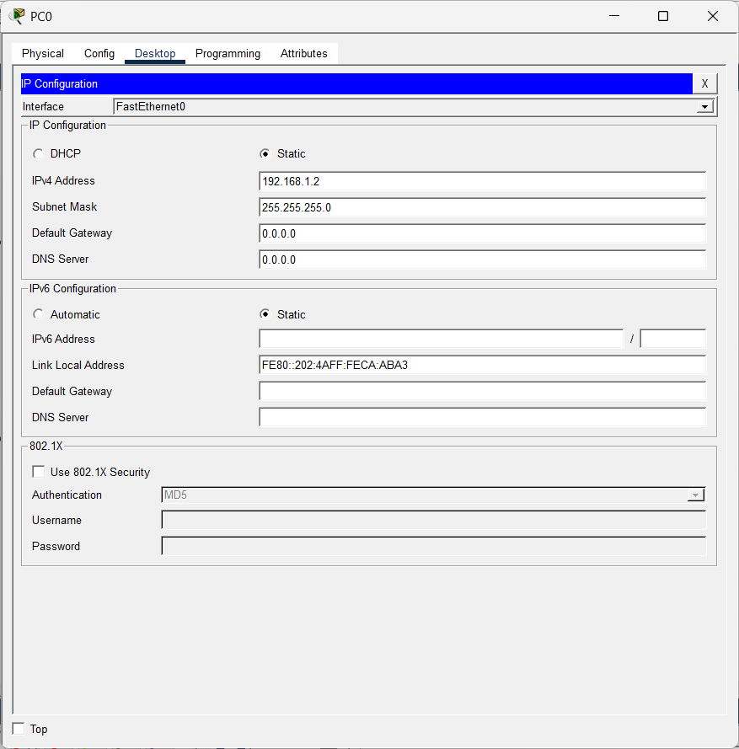
Ping Status :
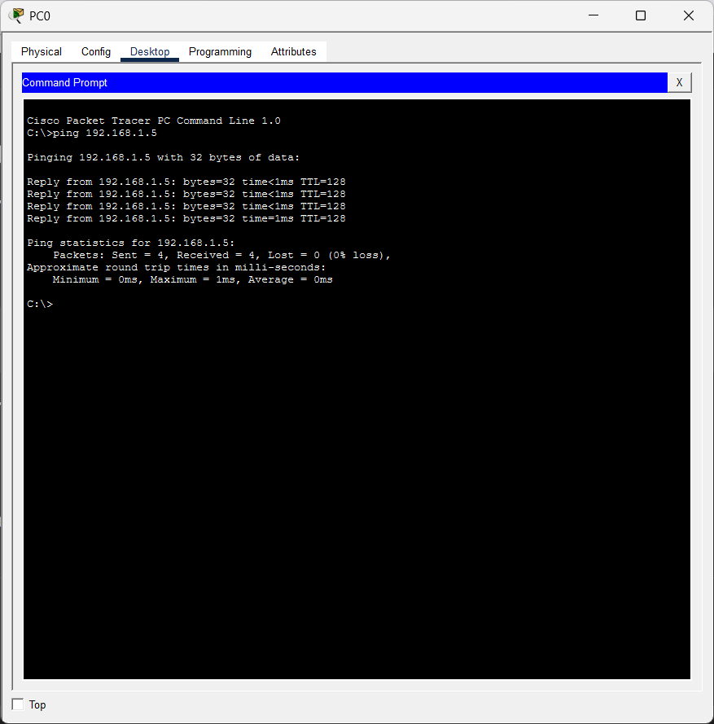
Simulation:
Initial Stage
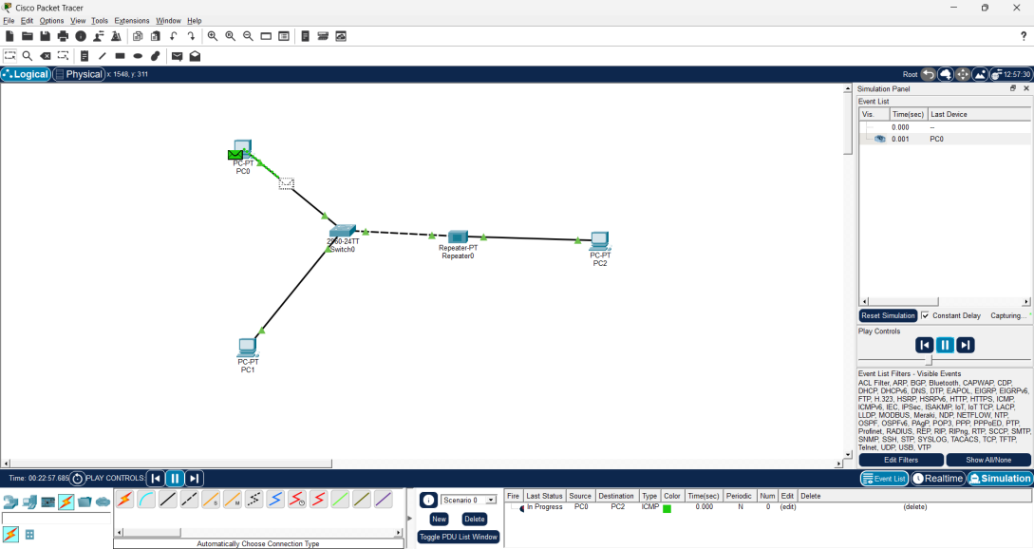
In progress
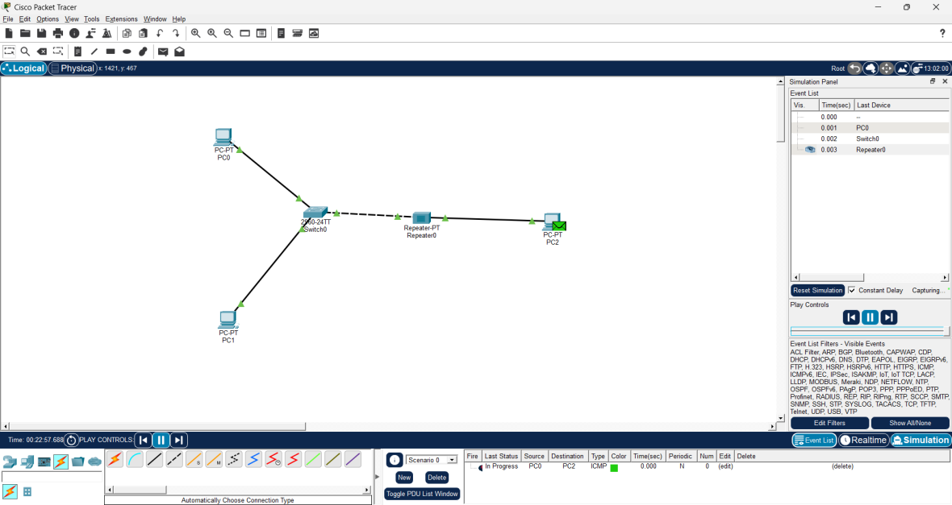
Successful
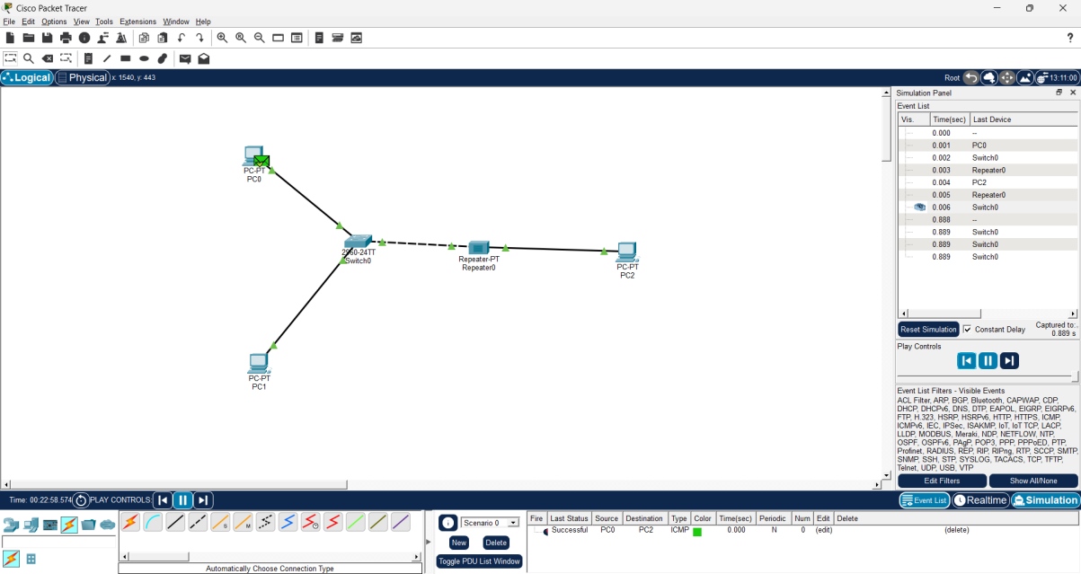

- Bridge:
Basic Structure:
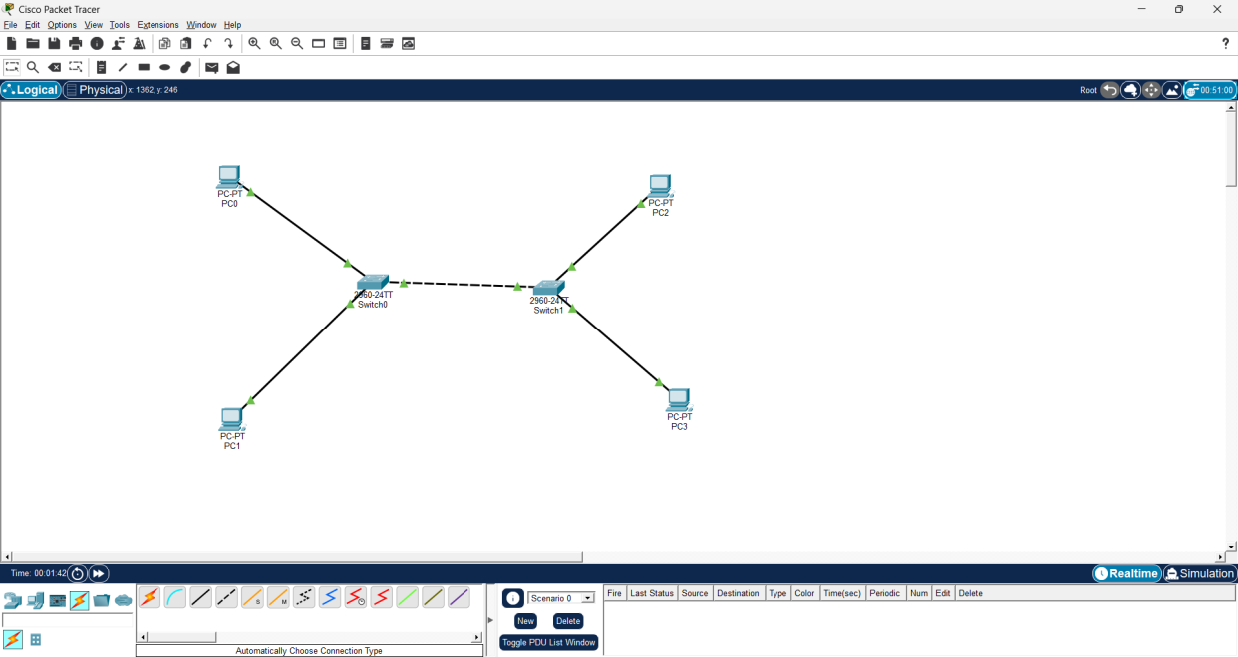
IP configuration:
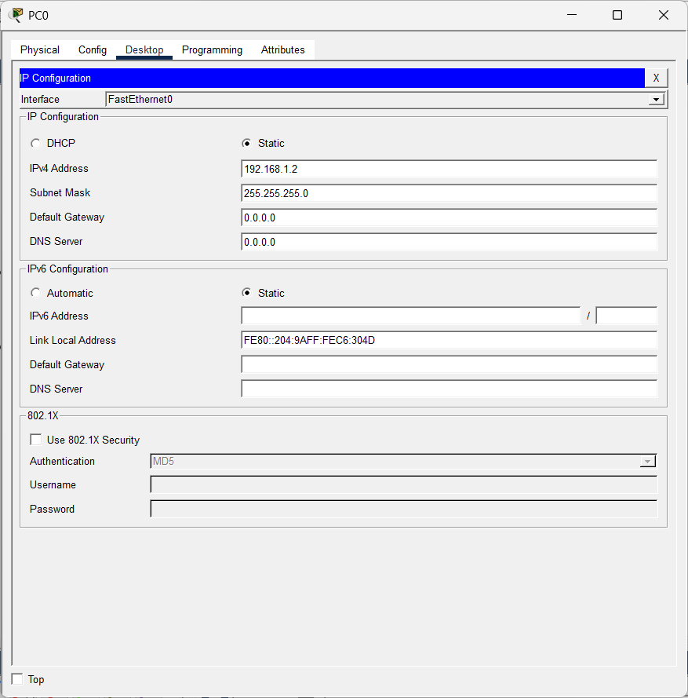
Ping Status:
Simulation:
Initial Stage:
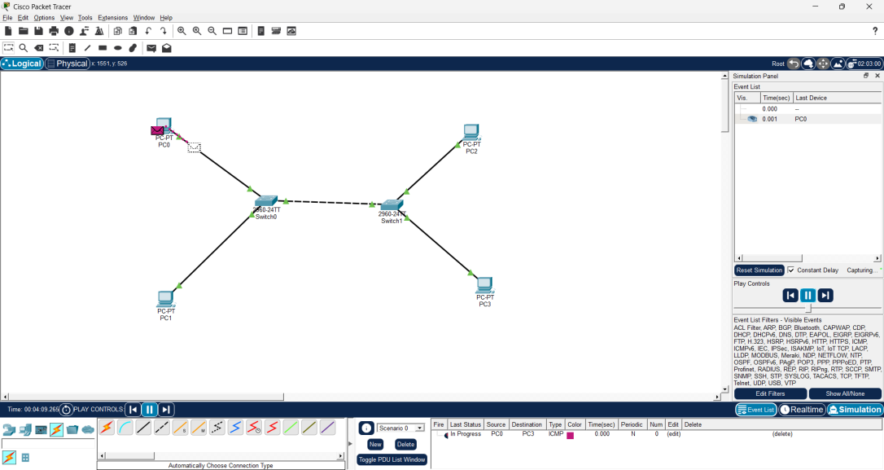
In Progress:
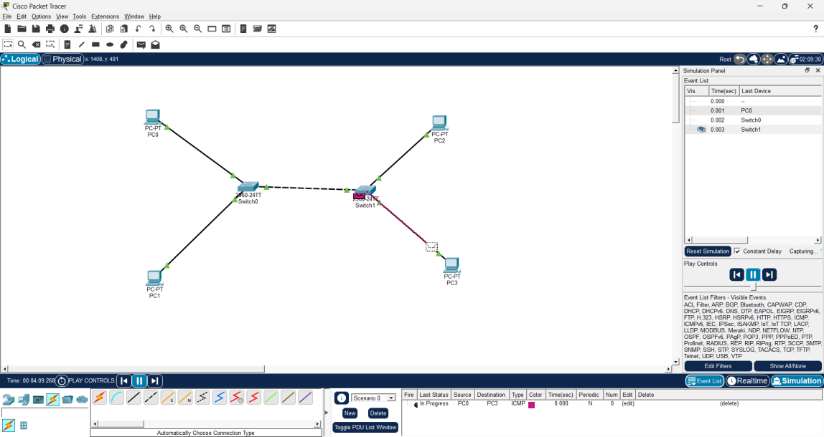
Successful:
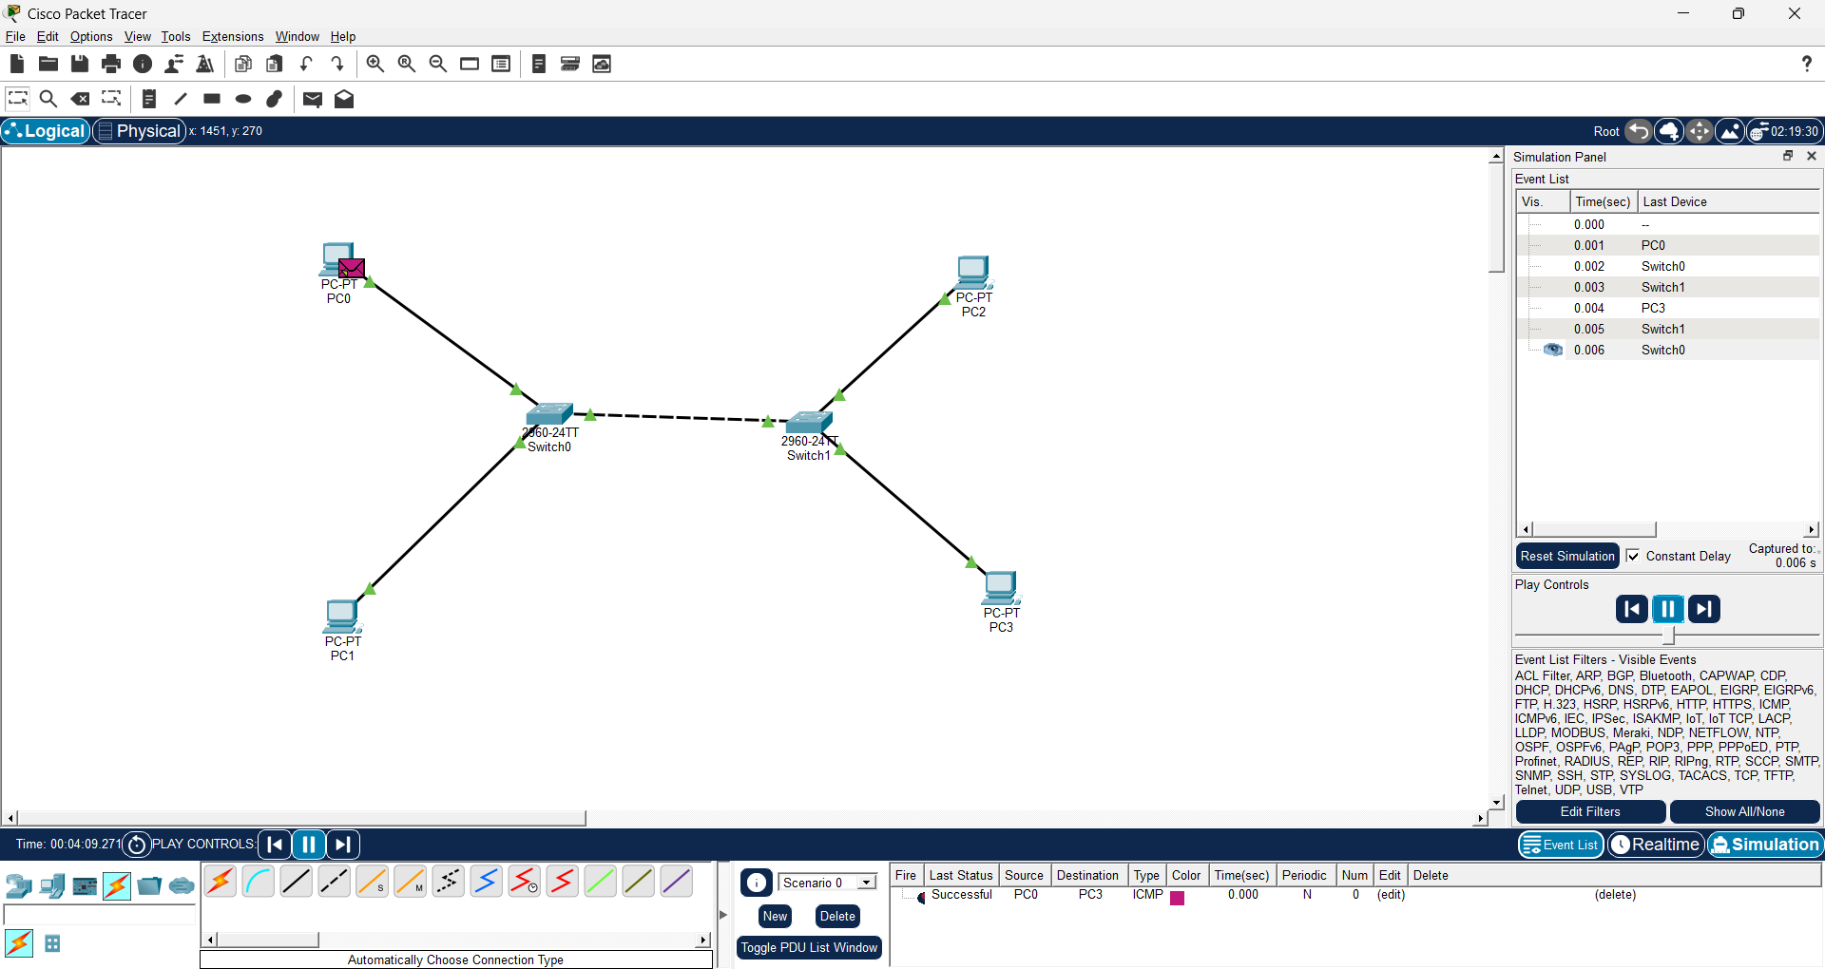

Result
Successfully configured two LANs and established communication between them using a router in Cisco Packet Tracer. The working of repeaters and bridges was also demonstrated successfully, and packet transmission was verified using Simulation Mode, confirming proper network connectivity and communication.

Exp No: 4 | Error Correcting Techniques using Hamming Code and Cyclic Redundancy Check
25.08.2026
Aim:
  - To implement an error detecting and correcting technique using Hamming Code in Python.
  - To implement an error detecting technique using Cyclic Redundancy Check (CRC) in Python.
Objective:
  - To understand the concept of error detection and correction in data communication.
  - To calculate the number of redundant (parity) bits required for a given length of data using Hamming Code.
  - To write a Python program that encodes data using Hamming Code, introduces a bit error, and detects and corrects it.
  - To write a Python program that implements CRC for error detection using polynomial (modulo-2) division.
  - To verify the correctness of both techniques using sample test data.
Simulation Tool:
- Python (IDLE / VS Code / Google Colab)
Theory:
Error detection and correction techniques are used at the Data Link Layer to ensure reliable transmission of data over a communication channel that may introduce noise or interference, causing bits to be altered during transmission.
Hamming Code is an error detecting and single-bit error correcting code developed by R. W. Hamming. It works by adding redundant (parity) bits to the original data at positions that are powers of two (1, 2, 4, 8, ...). Each parity bit is computed over a specific subset of the data bits, chosen based on the binary representation of the bit positions it covers. At the receiver, the same parity checks are recomputed; if all checks pass, no error has occurred. If one or more checks fail, the sum of the failed parity positions directly gives the position of the erroneous bit, which can then be flipped to correct it. Hamming Code can detect up to two-bit errors and correct single-bit errors.
Cyclic Redundancy Check (CRC) is an error-detecting code commonly used in digital networks and storage devices to detect accidental changes to raw data. The sender and receiver agree on a fixed generator polynomial (key). The sender appends (n-1) zero bits to the data (where n is the length of the generator) and performs binary (modulo-2, XOR-based) division of this augmented data by the generator polynomial.
The remainder obtained is the CRC checksum, which is appended to the original data to form the transmitted codeword. At the receiver's end, the received codeword is divided by the same generator polynomial; if the remainder is zero, the data is assumed to be error free, otherwise an error is detected.
Procedure - Algorithm:
a. Hamming Code (Generation): Determine the number of parity bits r required, such that 2^r >= m + r + 1, where m is the number of data bits.
• Place the data bits and parity bits into a codeword of length (m + r), with parity bits occupying positions that are powers of two.
• Calculate each parity bit by XOR-ing all bit positions whose binary representation includes that parity bit's position.
• At the receiver, recompute all parity checks on the received codeword.
• Add up the positions of the failed checks to get the position of the error bit (0 indicates no error); flip that bit to correct it.
a. CRC (Generation & Checking): Choose a generator polynomial (key) known to both sender and receiver.
• Append (n-1) zeros to the data, where n is the length of the key.
• Perform modulo-2 (XOR) division of the augmented data by the key; the remainder is the CRC.
• Append the CRC to the original data to form the transmitted codeword.
• At the receiver, divide the received codeword by the same key; a non-zero remainder indicates a transmission error.
Program:
Hamming Code (Error Detection & Correction)
# ============================================================
# Practical 4: Error Correcting/Detecting Techniques
# Part A - Hamming Code (Error Detection & Correction)
# ============================================================

def num_parity_bits(m):
r = 0
while (2 ** r) < (m + r + 1):
r += 1
return r

def is_power_of_two(n):
return n != 0 and (n & (n - 1)) == 0

def generate_hamming_code(data):
m = len(data)
r = num_parity_bits(m)
total = m + r

code = [0] * (total + 1)
j = 0

for i in range(1, total + 1):
if not is_power_of_two(i):
code[i] = int(data[j])
j += 1

for i in range(r):
pos = 2 ** i
parity = 0

for k in range(1, total + 1):
if k & pos:
parity ^= code[k]

code[pos] = parity

return ''.join(str(b) for b in code[1:])

def detect_and_correct(received):
total = len(received)
code = [0] + [int(b) for b in received]

r = num_parity_bits(total)
error_pos = 0

for i in range(r):
pos = 2 ** i

if pos > total:
continue

parity = 0

for k in range(1, total + 1):
if k & pos:
parity ^= code[k]

if parity != 0:
error_pos += pos

if error_pos:
print("Error detected at bit position:", error_pos)
code[error_pos] ^= 1
print("Error corrected.")
else:
print("No error detected.")

return ''.join(str(b) for b in code[1:])

def hamming_demo():
print("=" * 50)
print("HAMMING CODE")
print("=" * 50)

data = "1011"

codeword = generate_hamming_code(data)

print("Original data:", data)
print("Generated Hamming code:", codeword)

# Introducing a single-bit error
error_bit_index = 2

received = list(codeword)

if received[error_bit_index] == '0':
received[error_bit_index] = '1'
else:
received[error_bit_index] = '0'

received = ''.join(received)

print("Received code with error:", received)

corrected = detect_and_correct(received)

print("Corrected code:", corrected)

if corrected == codeword:
print("Correction successful!")
else:
print("Correction failed.")

hamming_demo()
Part B: Cyclic Redundancy Check (CRC)
# ============================================================
# PART B: CYCLIC REDUNDANCY CHECK (CRC)
# ============================================================
def xor(a, b):
return ''.join(
'0' if a[i] == b[i] else '1'
for i in range(1, len(b))
)

def mod2_divide(dividend, divisor):

pick = len(divisor)
tmp = dividend[:pick]

while pick < len(dividend):

if tmp[0] == '1':
tmp = xor(divisor, tmp) + dividend[pick]
else:
tmp = xor('0' * pick, tmp) + dividend[pick]

pick += 1

if tmp[0] == '1':
tmp = xor(divisor, tmp)
else:
tmp = xor('0' * pick, tmp)

return tmp

def crc_encode(data, key):

appended = data + '0' * (len(key) - 1)

remainder = mod2_divide(appended, key)

return data + remainder

def crc_check(received, key):

remainder = mod2_divide(received, key)

return remainder, remainder.count('1') == 0

def crc_demo():

print()
print("=" * 55)
print("PART B: CYCLIC REDUNDANCY CHECK (CRC)")
print("=" * 55)

data = "11010011101100"
key = "1011"

codeword = crc_encode(data, key)

print("Original data :", data)
print("Generator (key) :", key)
print("Transmitted codeword :", codeword)

# Case 1: No error
remainder, ok = crc_check(codeword, key)

print("\nReceiver check (no error introduced):")
print(
"Remainder =",
remainder,
"->",
"No error detected" if ok else "Error detected"
)

# Case 2: Introduce error
corrupted = list(codeword)

corrupted[4] = (
'1' if corrupted[4] == '0' else '0'
)

corrupted = ''.join(corrupted)

remainder, ok = crc_check(corrupted, key)

print("\nReceiver check (error introduced):")
print("Corrupted code =", corrupted)

print(
"Remainder =",
remainder,
"->",
"No error detected" if ok else "Error detected"
)

# ---------------- MAIN PROGRAM ----------------

if __name__ == "__main__":

crc_demo()
Outputs:

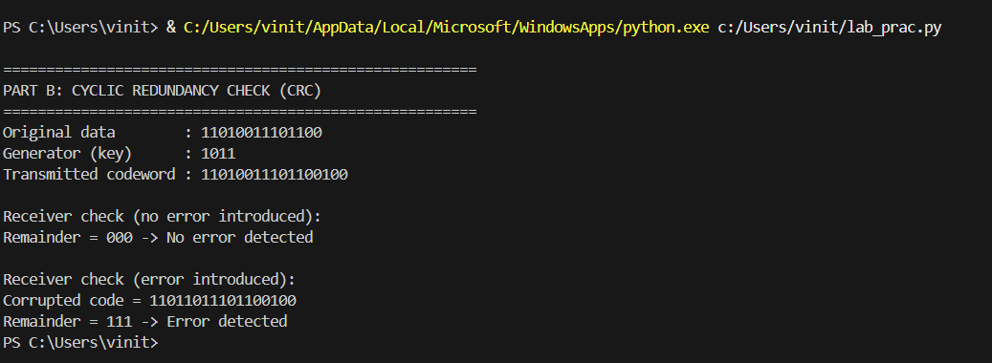
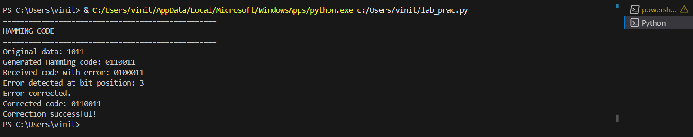

Result:
• The Hamming Code technique was successfully implemented in Python; a single-bit error introduced in the transmitted codeword was correctly detected and corrected at the receiver.
References:
1. https://www.geeksforgeeks.org/hamming-code-in-computer-network/
2. https://www.geeksforgeeks.org/computer-networks/error-detection-in-computer-networks/
3. https://www.tutorialspoint.com/cyclic-redundancy-check-crc

Exp No: 5 | Implementation of Data Link Layer (DLL) Protocols -Stop and Wait ARQ, Go-Back-N ARQ and Selective Repeat ARQ
27.08.2026

Aim:
To write and execute a Python program to implement and simulate various Data
Link Layer (DLL) error-control protocols - Stop-and-Wait ARQ, Go-Back-N ARQ, and
Selective Repeat ARQ - and to understand their mechanisms for achieving reliable
data transmission.
Objective:
1. To understand the basic principles of Automatic Repeat reQuest (ARQ)
protocols used at the Data Link Layer.
2. To implement the Stop-and-Wait ARQ protocol using Python.
3. To implement the Go-Back-N ARQ protocol using Python.
4. To implement the Selective Repeat ARQ protocol using Python.
5. To simulate frame transmission, acknowledgements (ACKs), frame loss, and
retransmission.
Simulation Tool:
Python (IDLE / VS Code / Google Colab)
Theory:
Automatic Repeat reQuest (ARQ) refers to a set of error-control protocols used at the
Data Link Layer to achieve reliable data transmission over an unreliable channel, by
using acknowledgements and timeouts to detect and recover from lost or corrupted
frames.
Stop-and-Wait ARQ is the simplest form of ARQ, in which the sender transmits a
single frame and then waits for an acknowledgement (ACK) from the receiver before
sending the next frame. If the ACK is not received within a timeout period (because
the frame or the ACK was lost), the sender retransmits the same frame. Although
simple, this protocol results in poor channel utilization since only one frame can be in
transit at a time.
Go-Back-N ARQ is a sliding-window protocol in which the sender can transmit up to
N frames (the window size) without waiting for individual acknowledgements. The
receiver only accepts frames in order and sends a cumulative acknowledgement for
the last correctly received in-order frame. If a frame is lost or an error occurs, the
receiver discards all subsequent out-of-order frames, and the sender must go back
and retransmit all frames starting from the lost one, even if some of them were
received correctly.
Selective Repeat ARQ improves upon Go-Back-N by allowing the receiver to accept
and buffer out-of-order frames that arrive correctly, and individually acknowledge
each frame. Only the specific frame(s) that were lost or corrupted are retransmitted
by the sender, rather than the entire window. This makes more efficient use of the
available bandwidth, at the cost of additional buffering and bookkeeping complexity
at both the sender and the receiver.
Procedure - Algorithm:
a. Stop-and-Wait ARQ: Sender transmits a frame and starts a timer.
• If the receiver receives the frame correctly, it sends an ACK.
• If the sender receives the ACK before the timer expires, it sends the next
frame; otherwise, it retransmits the same frame.
• Repeat until all frames have been successfully delivered and acknowledged.
b. Go-Back-N ARQ: Sender maintains a window of size N and transmits all
frames within the window without waiting for individual ACKs.
• Receiver accepts frames only in order and sends a cumulative ACK for the last
in-order frame received.
• If a frame is lost, the receiver discards later out-of-order frames until the
missing one is received.
• On timeout, the sender retransmits all frames starting from the
lost/unacknowledged frame.
c. Selective Repeat ARQ: Sender maintains a window of size N and transmits
all frames within the window.
• Receiver accepts and buffers correctly received out-of-order frames and sends
an individual ACK for each frame received.
• If a specific frame is lost, only that frame is retransmitted by the sender after
a timeout.
• The window slides forward as frames are acknowledged, in order.

Program:
# ============================================================
# Practical 5: Data Link Layer (DLL) ARQ Protocols
# 1. Stop-and-Wait ARQ
# 2. Go-Back-N ARQ
# 3. Selective Repeat ARQ
# ============================================================

import random

random.seed(7) # fixed seed so the run is reproducible for the record

FRAME_LOSS_PROB = 0.3 # probability a frame or ACK is lost in transit

def frame_lost():
return random.random() < FRAME_LOSS_PROB

# ---------------- 1. STOP-AND-WAIT ARQ ----------------

def stop_and_wait(total_frames):
print("\n" + "=" * 55)
print("STOP-AND-WAIT ARQ")
print("=" * 55)

frame = 0

while frame < total_frames:
print(f"Sender : sending frame {frame}")

if frame_lost():
print(f" !! frame {frame} lost in transit")
print(f"Sender : timeout, retransmitting frame {frame}")
continue

print(f"Receiver: frame {frame} received correctly")

if frame_lost():
print(" !! ACK lost in transit")
print(f"Sender : timeout, retransmitting frame {frame}")
continue

print(f"Receiver: sending ACK{frame}")
print(f"Sender : ACK{frame} received, moving to next frame")

frame += 1

print("All frames delivered successfully (Stop-and-Wait).")

# ---------------- 2. GO-BACK-N ARQ ----------------

def go_back_n(total_frames, window_size=4):
print("\n" + "=" * 55)
print(f"GO-BACK-N ARQ (window size = {window_size})")
print("=" * 55)

base = 0
next_seq = 0
expected = 0

while base < total_frames:

# Send every frame currently within the window
while next_seq < base + window_size and next_seq < total_frames:
print(f"Sender : sending frame {next_seq}")
next_seq += 1

# Receiver processes frames in order
# Sender waits for cumulative ACK
while base < next_seq:
frame = base

if frame != expected:
base += 1
continue

if frame_lost():
print(
f" !! frame {frame} lost -> Go-Back-N: "
f"resend frames {frame} to {next_seq - 1}"
)

# Roll back and resend the window
next_seq = frame
break

print(
f"Receiver: frame {frame} received in order, "
f"sending ACK{frame}"
)

expected += 1
base += 1

else:
continue

continue

print("All frames delivered successfully (Go-Back-N).")

# ---------------- 3. SELECTIVE REPEAT ARQ ----------------

def selective_repeat(total_frames, window_size=4):
print("\n" + "=" * 55)
print(f"SELECTIVE REPEAT ARQ (window size = {window_size})")
print("=" * 55)

acked = [False] * total_frames
base = 0

while base < total_frames:

window = [
f
for f in range(
base,
min(base + window_size, total_frames)
)
if not acked[f]
]

for frame in window:
print(f"Sender : sending frame {frame}")

if frame_lost():
print(f" !! frame {frame} lost in transit")
continue

print(
f"Receiver: frame {frame} received, "
f"buffering/delivering it"
)

if frame_lost():
print(f" !! ACK{frame} lost in transit")
continue

print(f"Receiver: sending ACK{frame}")

acked[frame] = True

print(f"Sender : ACK{frame} received")

# Move the base forward for consecutively acknowledged frames
while base < total_frames and acked[base]:
base += 1

if window and not any(acked[f] for f in window):
print(
f"Sender : no progress this round, "
f"retransmitting unacked frames {window}"
)

print("All frames delivered successfully (Selective Repeat).")

# ============================================================
# MAIN PROGRAM
# ============================================================

if __name__ == "__main__":

NUM_FRAMES = 6

# Stop-and-Wait ARQ
stop_and_wait(NUM_FRAMES)

# Go-Back-N ARQ
random.seed(11)
go_back_n(NUM_FRAMES, window_size=4)

# Selective Repeat ARQ
random.seed(3)
selective_repeat(NUM_FRAMES, window_size=4)

Output:
Stop-and-Wait ARQ – Output:
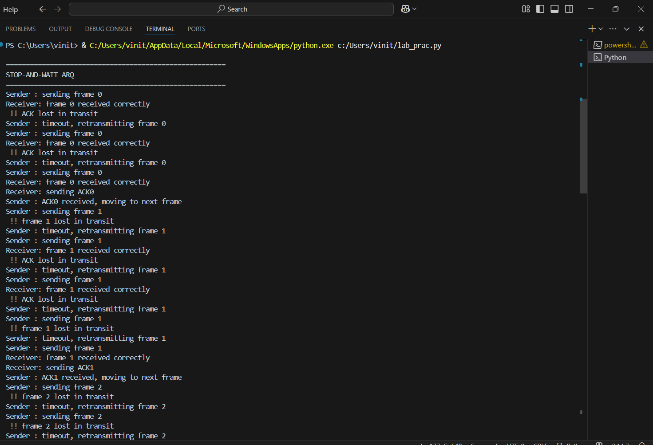

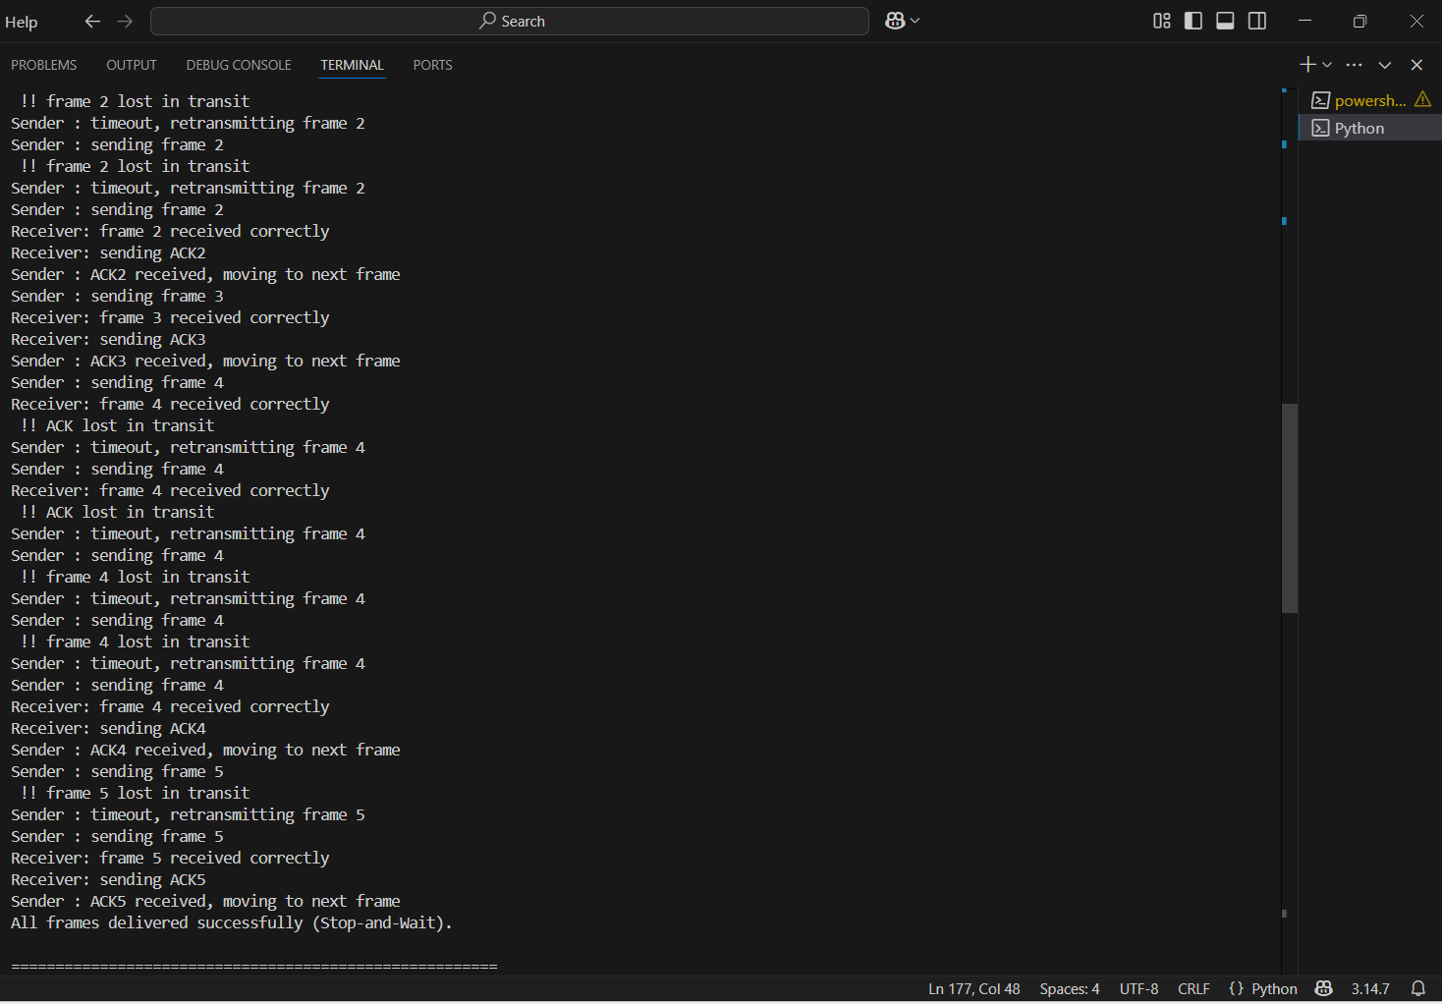

Go-Back-N ARQ – Output & Selective Repeat ARQ – Output:
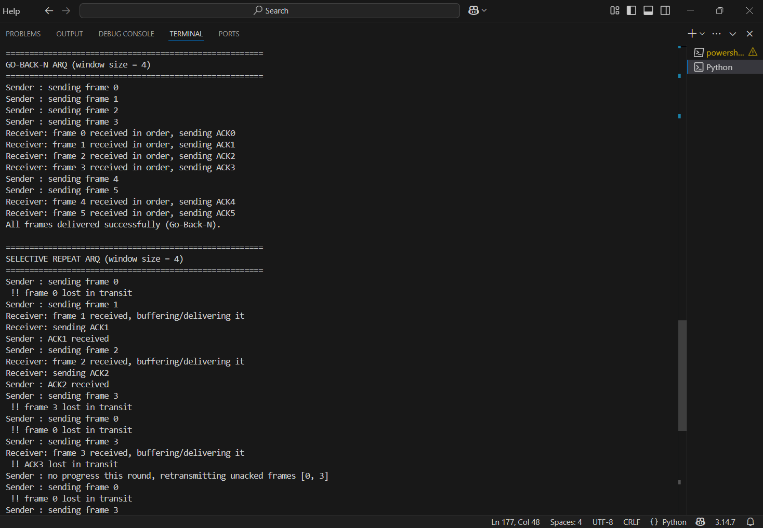

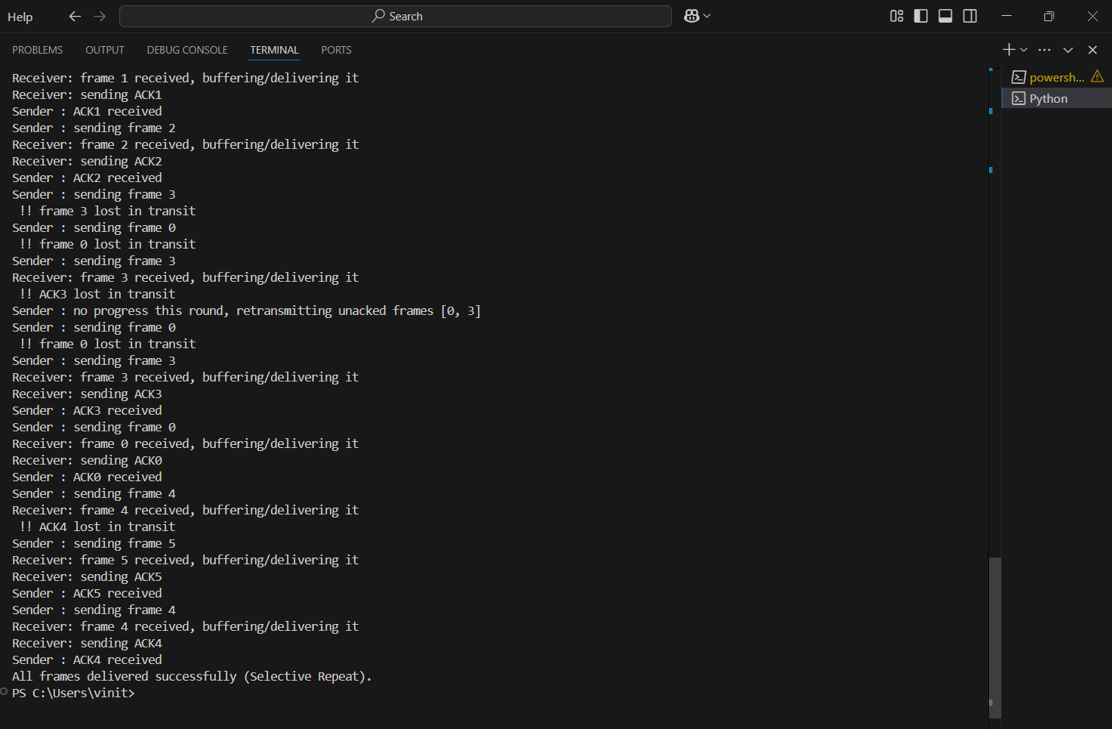

Result:
The Stop-and-Wait, Go-Back-N, and Selective Repeat ARQ protocols were
successfully implemented and simulated in Python, demonstrating frame
transmission, acknowledgement, frame loss, and retransmission behaviour for each
protocol.

References:
1. https://www.geeksforgeeks.org/computer-networks/stop-and-wait-arq/
2.
https://www.geeksforgeeks.org/computer-networks/sliding-window-protocol-set-2-recei
ver-side/
3. https://www.tutorialspoint.com/what-is-selective-repeat-protocol
4. https://www.javatpoint.com/computer-network-sliding-window-protocol

Exp No: 6 | Basic IPv6 Addressing with Cisco Packet Tracer
20-09-2026 | Basic IPv6 Addressing with Cisco Packet Tracer

Aim:
To demonstrate IPv6 Addressing using Cisco Packet Tracer.
Objective:
▪ Configuring a router in order to enable communication between two IPv6 networks.
Simulation Tool:
Cisco Packet Tracer
Theory:
IPv6 (Internet Protocol version 6) is the most recent version of the Internet Protocol, designed to succeed IPv4. The most notable difference is its address space: IPv6 uses 128-bit addresses (written as eight groups of four hexadecimal digits, separated by colons, e.g., 2001:0db8:85a3:0000:0000:8a2e:0370:7334) compared to IPv4's 32-bit addresses. This allows for a practically inexhaustible number of unique addresses.
A Link-Local address is automatically assigned to every IPv6-enabled interface. These addresses (starting with FE80::/10) are used for communication within the local network segment (link) and are not routable beyond that link. They are essential for neighbour discovery and router discovery.
IPv6 routers must have IPv6 unicast routing enabled via the ipv6 unicast-routing command, and each interface must be assigned a global unicast address as well as a link-local address. Hosts can auto-configure their own addresses using Stateless Address Autoconfiguration (SLAAC) by combining the router-advertised prefix with their own interface identifier.
Procedure:
1. Start up Cisco Packet Tracer, and place a couple of end devices of your choice.
2. Form a LAN by connecting the devices with a switch; repeat to form a second LAN, then connect them both with a router.
3. Open the Command Line Interface (CLI) for the router and enable IPv6 addressing using: ipv6 unicast-routing
4. Set an IPv6 address for each router port and a separate link-local address using the ipv6 address command.
5. Configure an IP for each end device; use the auto-configuration option to let the device automatically determine the address by communicating with the router.
6. Test whether the connection works by pinging a device from one LAN to another using its IPv6 address.

Output: (Simulation Screenshots):
Network topology
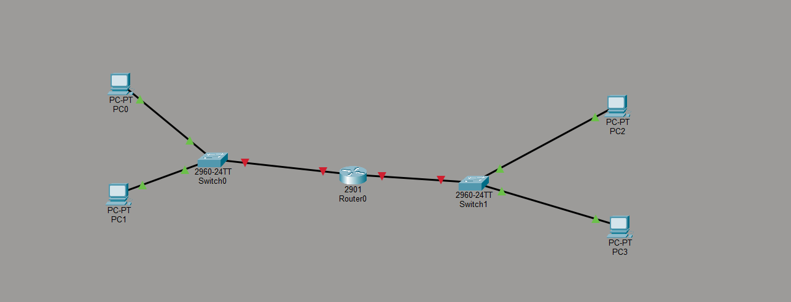
Router Configuration -
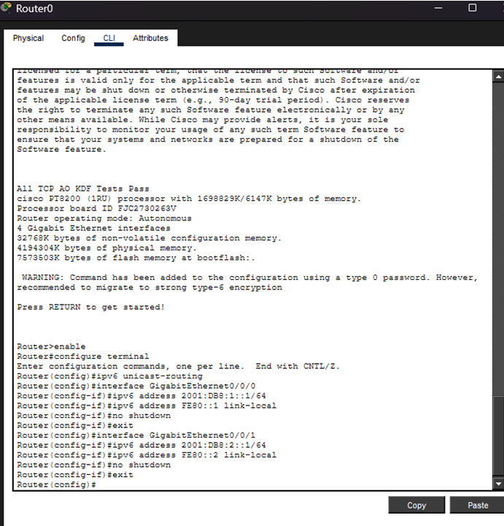
Router Status -
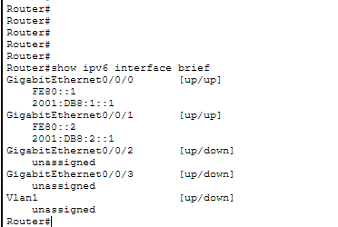
Configure PC0
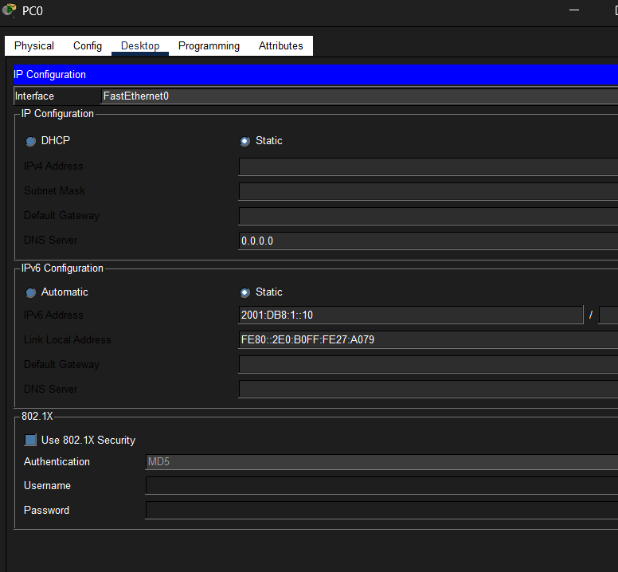
Configure PC1
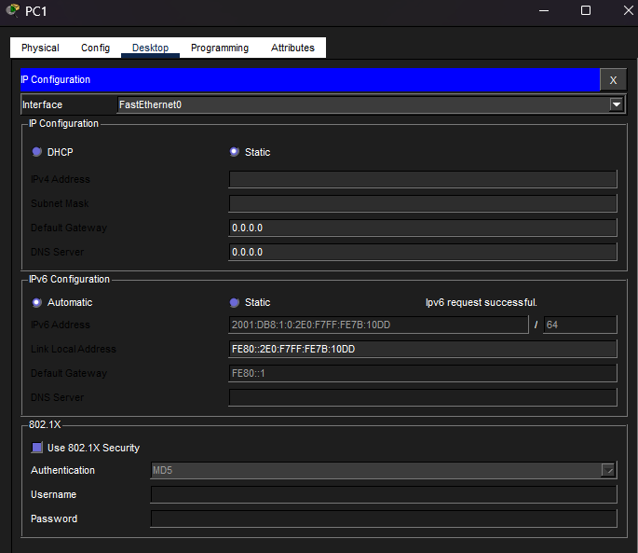
Successful ping
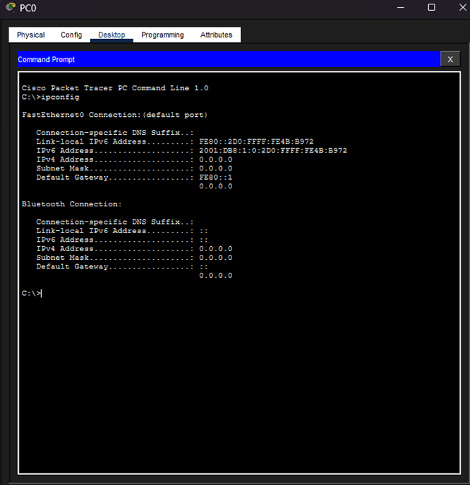
Result:
IPv6 addressing was successfully demonstrated using Cisco Packet Tracer. Two separate LANs were configured with IPv6 addresses, the router was enabled for IPv6 unicast routing, and successful communication between the two LANs was verified using the ping command.
References:
1. https://www.netacad.com/courses/packet-tracer
2. https://skillsforall.com/course/getting-started-cisco-packet-tracer
3. https://www.cisco.com/c/en/us/support/docs/ip/ip-version-6-ipv6/113328-ipv6-config-guide.html
4. https://www.geeksforgeeks.org/internet-protocol-version-6-ipv6/

Exp No: 7 | Implementation of ARP using Cisco Packet Tracer
28.09.2026 | Implementation of ARP using Cisco Packet Tracer

Aim:
To demonstrate ARP (Address Resolution Protocol) using Cisco Packet Tracer.
Objective:
▪ Configuring a setup involving switches, end devices and a server in order to demonstrate the working of the Address Resolution Protocol.
Simulation Tool:
Cisco Packet Tracer
Theory:
ARP (Address Resolution Protocol) is a communication protocol used for discovering the link-layer address (MAC address) associated with a given internet layer address (IP address). ARP operates within the Data Link Layer and Network Layer boundary and is fundamental to communication in an Ethernet LAN.
When a host wants to communicate with another host on the same local network, it needs the destination's MAC address. It first checks its own ARP cache (a table mapping IP addresses to MAC addresses). If the mapping is not found, the host broadcasts an ARP Request packet to all devices on the network, asking "Who has IP address X? Tell me your MAC address." The host with that IP address replies with an ARP Reply containing its MAC address. This mapping is then cached by the requester for future use.
The command 'arp -a' displays the current ARP table (cache) of a device, showing the known IP-to-MAC address mappings. Initially, if no communication has taken place, the table is empty. After pinging another device, an entry is added to the ARP table for that device's IP and MAC address pair.
Procedure:
1. Start up Cisco Packet Tracer and place a few end devices of your choice.
2. Connect all of them using a switch to form a LAN.
3. For each device: double-click the device, go to the Desktop tab, click on IP Configuration and set an IP address.
4. Make sure to give them all similar IPs — if an address is p.q.r.s, keep the 'p', 'q', and 'r' values equal for all end devices.
5. Double-click any two of the devices, go to the Command Prompt, and type 'arp -a'. Observe the ARP table — it will show 'no entries found' initially.
6. From one device, ping another device in the LAN.
7. Now, ping the first device from that other device's Command Prompt.
8. Check the ARP tables of both devices again using 'arp -a' and observe the newly populated entries.
Output: (Simulation Screenshots):
Topology:
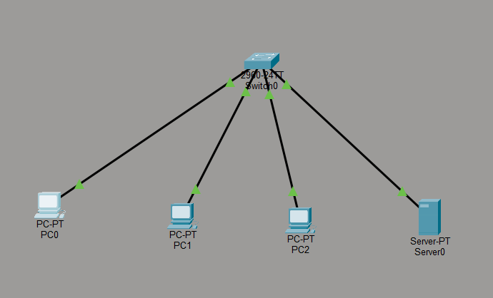
Configure PC0:
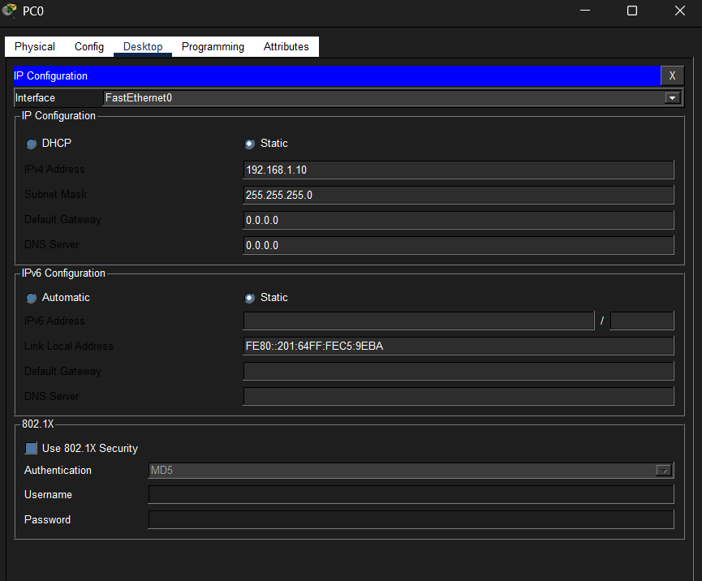
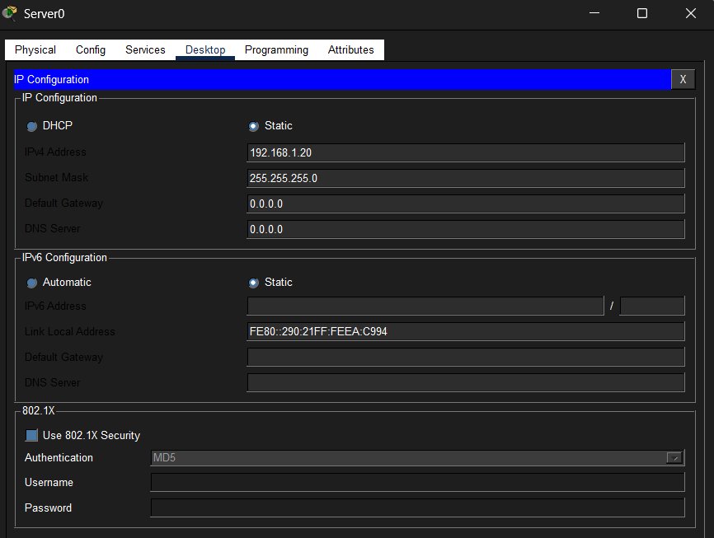
Initial ARP table
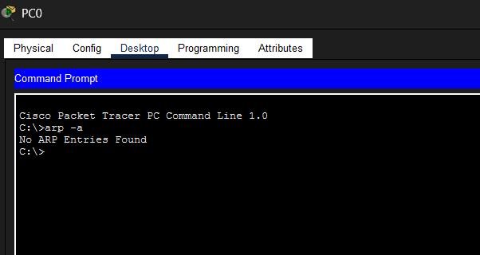
Successful ping and ARP table after ping for pc0:
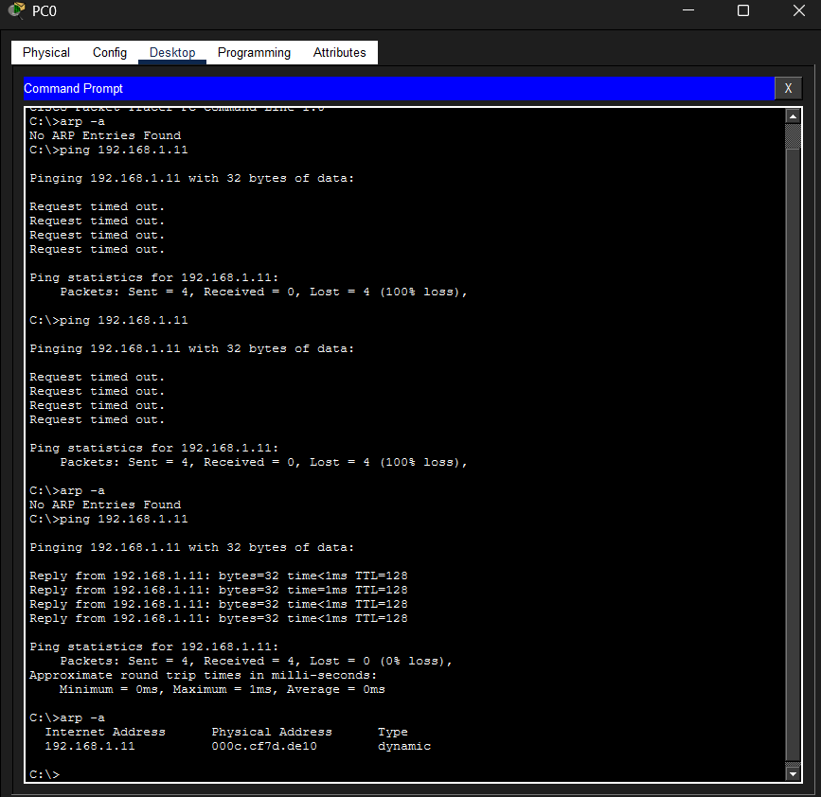
Successful ping and ARP table after ping for pc1:
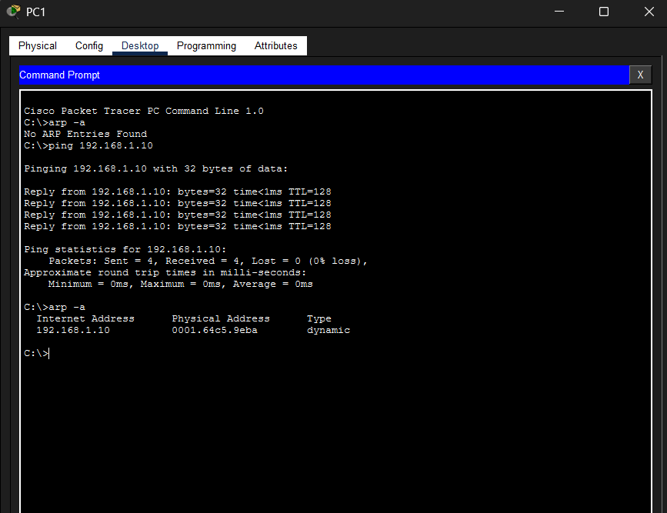
Simulation:
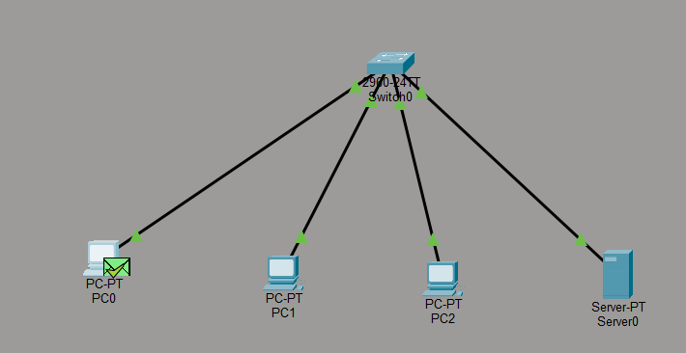
Result:
The working of ARP (Address Resolution Protocol) was successfully demonstrated using Cisco Packet Tracer. The ARP tables of the devices were initially empty, and after performing ping operations between the devices, the corresponding IP-to-MAC address mappings were populated in the ARP tables, confirming successful ARP resolution.
References:
1. https://www.netacad.com/courses/packet-tracer
2. https://skillsforall.com/course/getting-started-cisco-packet-tracer
3. https://www.geeksforgeeks.org/how-address-resolution-protocol-arp-works/
4. https://www.tutorialspoint.com/address-resolution-in-arp

Exp No: 8(A) | To configure a wireless network using a wireless router and end devices in Cisco Packet Tracer.
28.09.2026

Aim:
A. To configure a wireless network using Cisco Packet Tracer.
Objectives:
- To create a wireless network using a wireless router.
- To connect multiple end devices using Wi-Fi.
- To verify connectivity using the ping command.
Tools:
- Cisco Packet Tracer
- Wireless router
- PCs or laptops with wireless modules
Theory:
A wireless network allows devices such as PCs, laptops, and smartphones to communicate without physical cables using radio signals. In Cisco Packet Tracer, a wireless router acts as the central device that provides wireless connectivity and can automatically assign IP addresses to connected devices using DHCP.
The wireless network is identified by an SSID (Service Set Identifier). Security can be configured using a password to prevent unauthorized access. In this practical, the WPC300N wireless module is installed in the PCs so they can connect to the router wirelessly. Connectivity is verified using the ping command, which checks whether one device can communicate with another.

Procedure:
- Open Cisco Packet Tracer and drag a wireless router into the workspace.
- Add a few end devices, such as PCs or laptops.
- Double-click the router and open the GUI tab.
- Configure the wireless network:
  - Set the SSID (network name).
  - Select WEP security.
  - Set a wireless password.
- For each end device:
  - Open the Physical tab.
  - Turn off the device.
  - Replace the existing module with the WPC300N wireless module.
  - Turn the device back on.
- Open the PC's Desktop → PC Wireless → Connect tab.
- Select the configured SSID and enter the password.
- Repeat for all devices.
- Open Command Prompt on one PC and ping another PC's IP address.
Output: (Simulation Screenshots):
Complete Wireless Topology
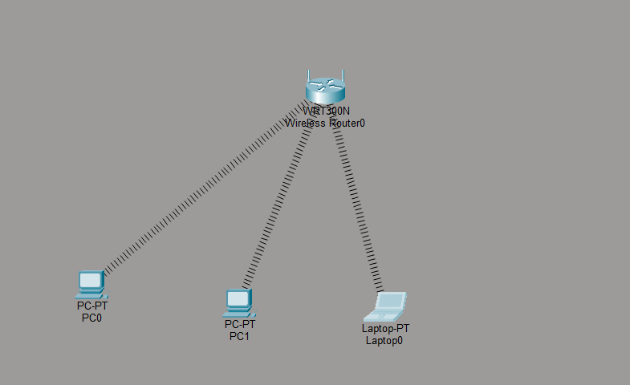
Wireless Router Configuration
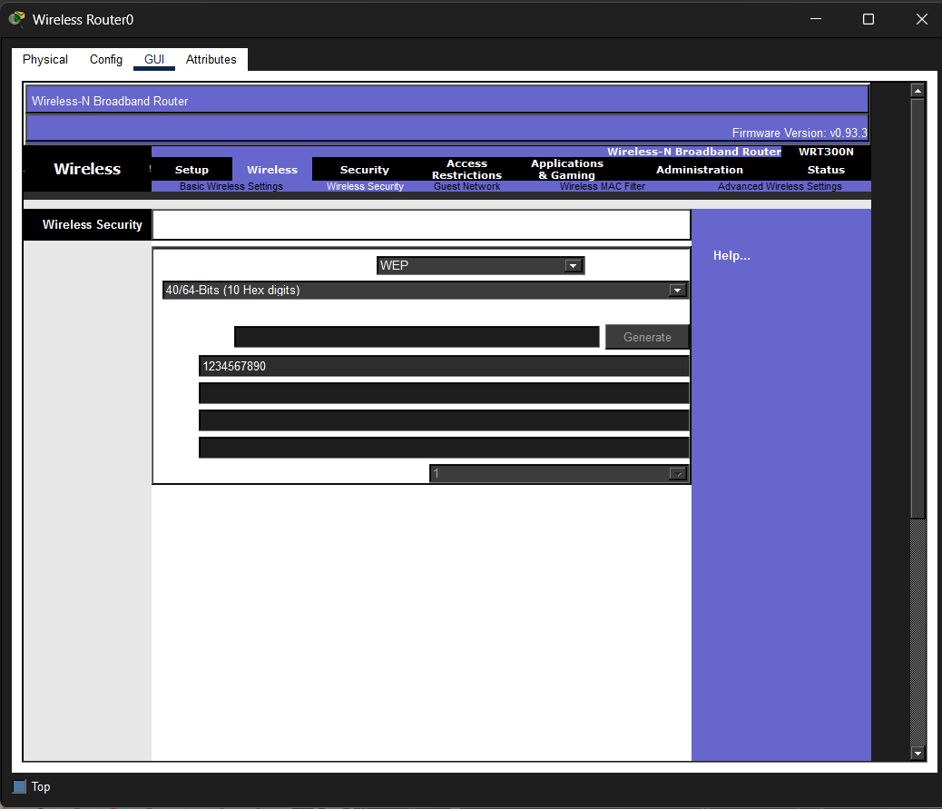
PC Wireless Connection
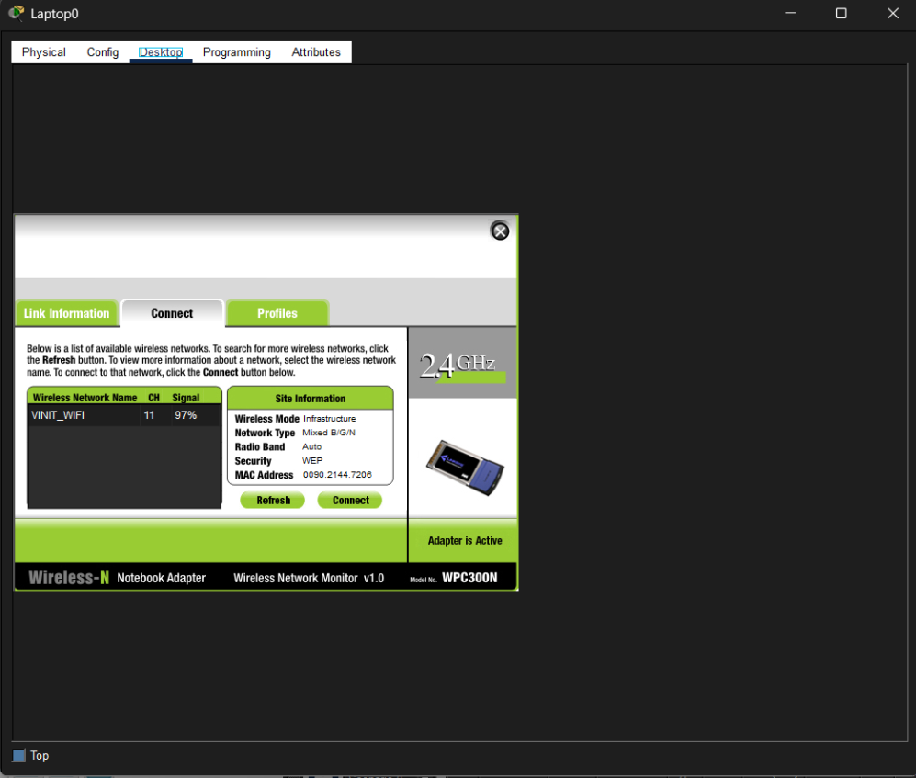
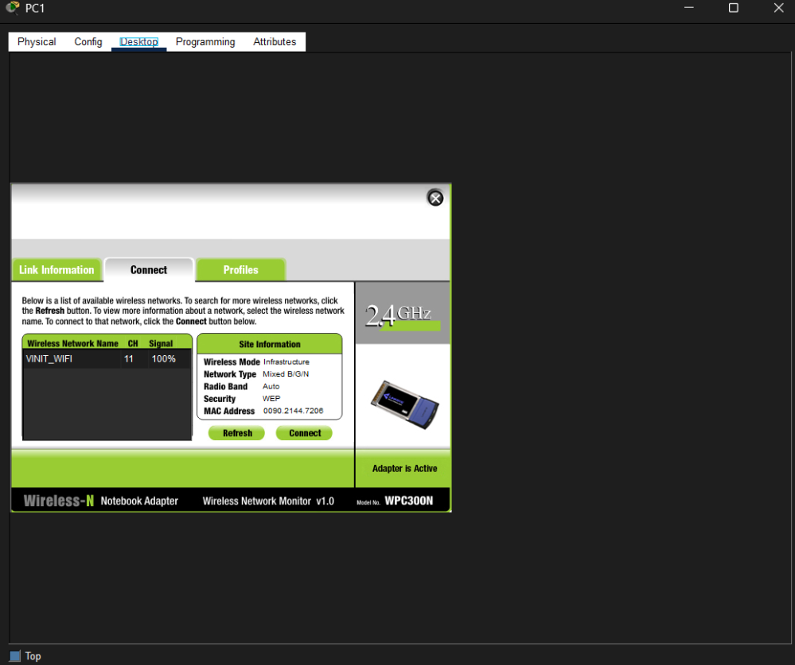
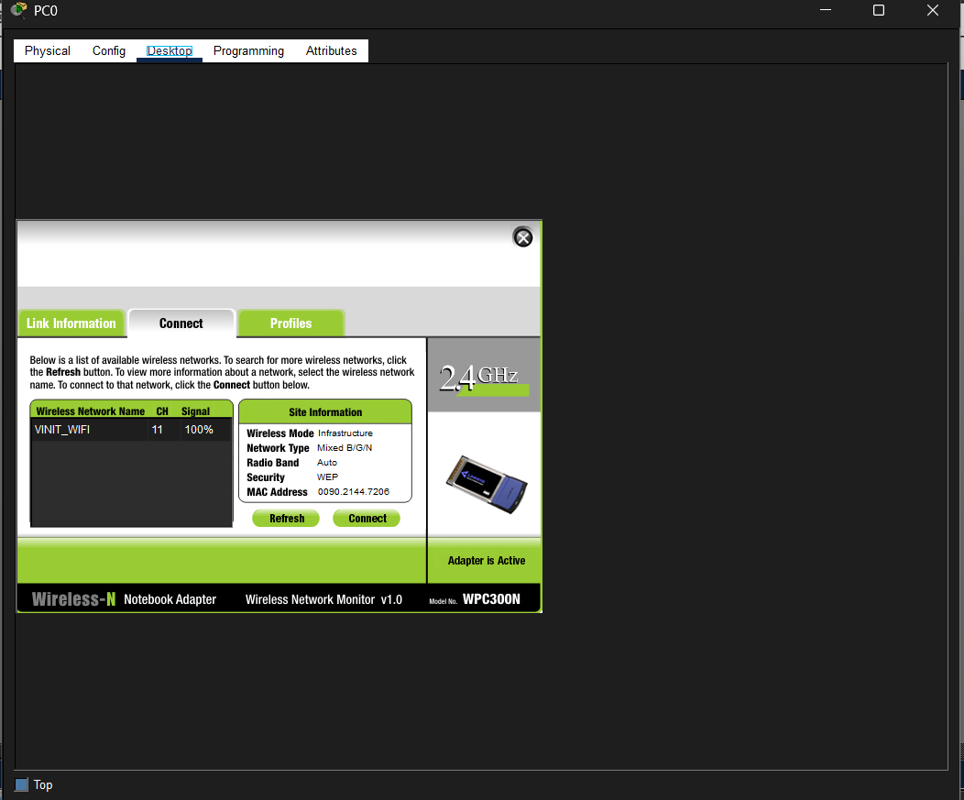

Successful Ping
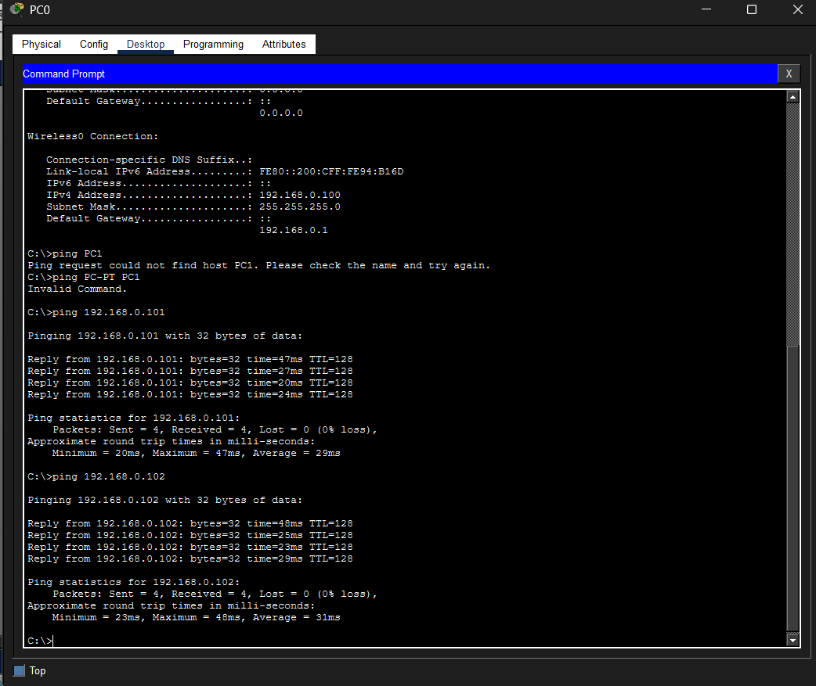
Result:
The wireless network was successfully configured in Cisco Packet Tracer using a wireless router and end devices. The devices connected through Wi-Fi, obtained IP addresses using DHCP, and connectivity was verified using the ping command.
References:
1. https://www.netacad.com/courses/packet-tracer
2. https://skillsforall.com/course/getting-started-cisco-packet-tracer
3. https://www.geeksforgeeks.org/how-address-resolution-protocol-arp-works/
4. https://www.tutorialspoint.com/address-resolution-in-arp

Exp No: 8(B) | To implement an IoT setup in Cisco Packet Tracer.
28.09.2026 | To implement an IoT setup in Cisco Packet Tracer.

Aim:
To implement an IoT setup in Cisco Packet Tracer.

Objective:
Configuring IoT network with smart devices.
Simulation Tool: Cisco Packet Tracer
Procedure: IoT
- Start Up: Cisco Packet Tracer, and select a few Home devices.
- Select a Home Gateway (Wireless Network Device) and drag it onto the workspace.
- Go to ‘Wireless’ in its Settings after double clicking it, and copy its SSID.
- Double click each device, go to ‘Config’ and select Home Gateway as the IoT server.
- Finally, select a Smartphone, double click, go to ‘Config’ and paste the SSID.
- You will now see all devices connected to the Gateway. Go to IoT Monitor in Desktop if you’d like to manipulate your chosen end devices through your Smartphone.
Output: (Simulation Screenshots):
Complete IoT Topology
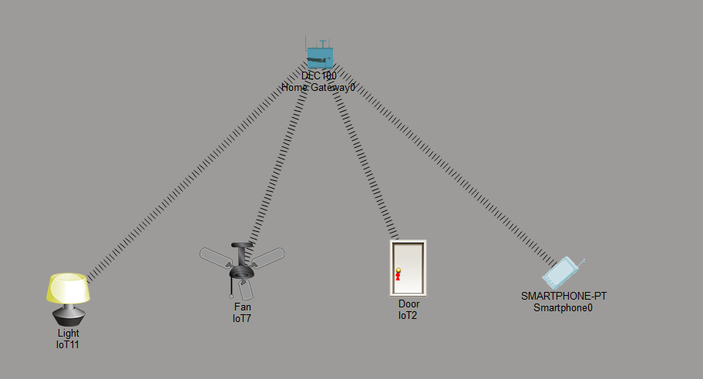
Home Gateway Configuration
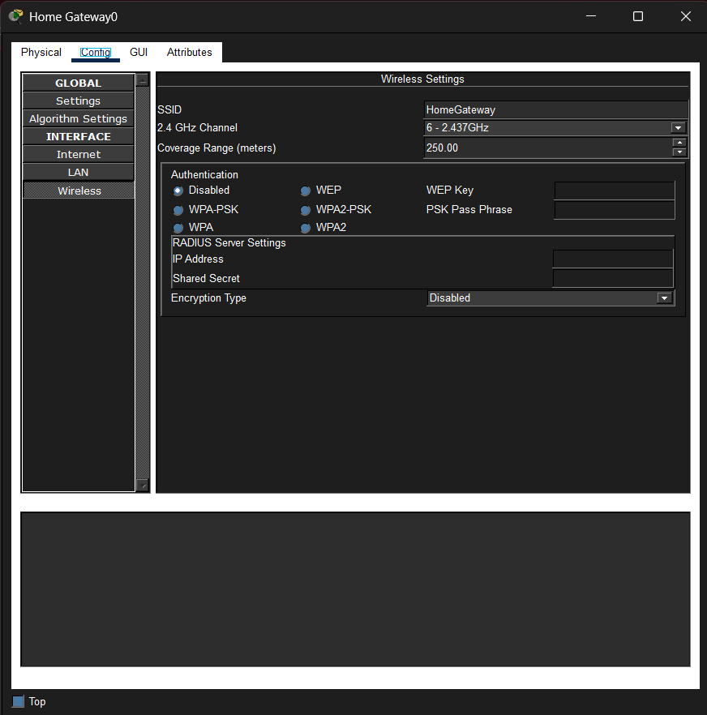

IoT Devices Connected
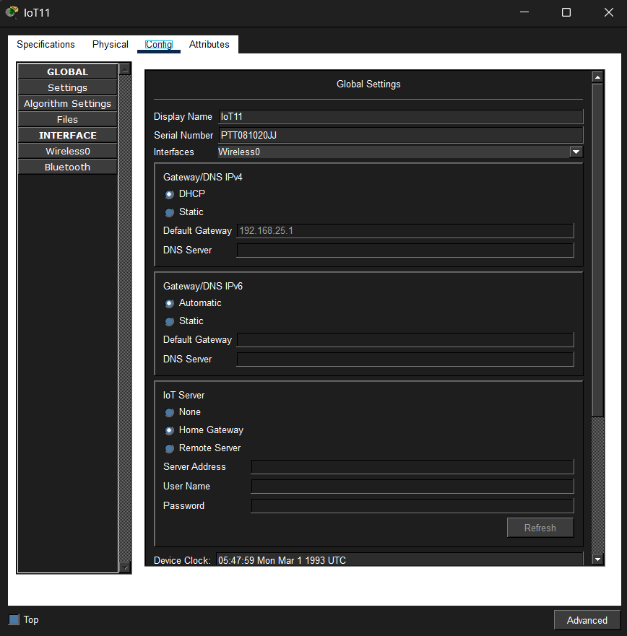
Smartphone IoT Monitor
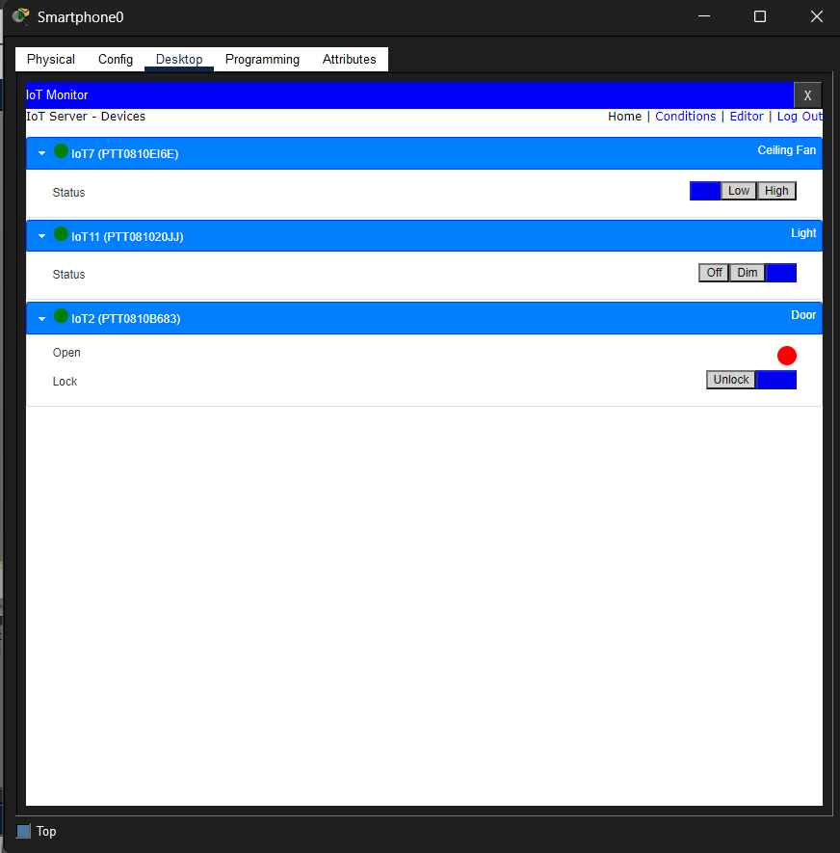

Result:
The IoT network was successfully configured in Cisco Packet Tracer using a Home Gateway, smart devices, and a smartphone to establish wireless communication and monitor/control the connected devices.
References:
1. https://www.netacad.com/courses/packet-tracer
2. https://skillsforall.com/course/getting-started-cisco-packet-tracer
3. https://www.geeksforgeeks.org/how-address-resolution-protocol-arp-works/
4. https://www.tutorialspoint.com/address-resolution-in-arp

Exp No: 9 | Develop a TCP client-server program
28.09.2026 | Develop a TCP client-server program

Aim:
To implement a TCP client-server program in Python where the client connects to a server and receives the server's current date and time.
Objective:
To implement TCP-based client-server communication for retrieving and
displaying the server’s current date and time at the client side.
Simulation Tool:
Python 3.x And VS Code / Python IDLE
Procedure: IoT
- Open VS Code and create a new folder for Practical 09.
- Create a Python file named server.py and write the TCP server program using the socket and datetime modules.
- Create another Python file named client.py and write the TCP client program using the socket module.
- In server.py, create a TCP socket using:
- IP address: 127.0.0.1
- Port number: 12345
- Run the server program first. The server waits for a client connection.
- Open a second terminal and run client.py.
- The client connects to the server using the same IP address and port number.
- Once the connection is established, the server obtains the current date and time using the datetime module.
- The server sends the date and time to the client through the TCP connection.
- The client receives the data and displays the server's current date and time on the terminal.
- Close the client and server sockets after communication is completed.
- Verify the successful TCP communication by checking the server connection message and the date/time displayed by the client.

Output: (Simulation Screenshots):
Server Program
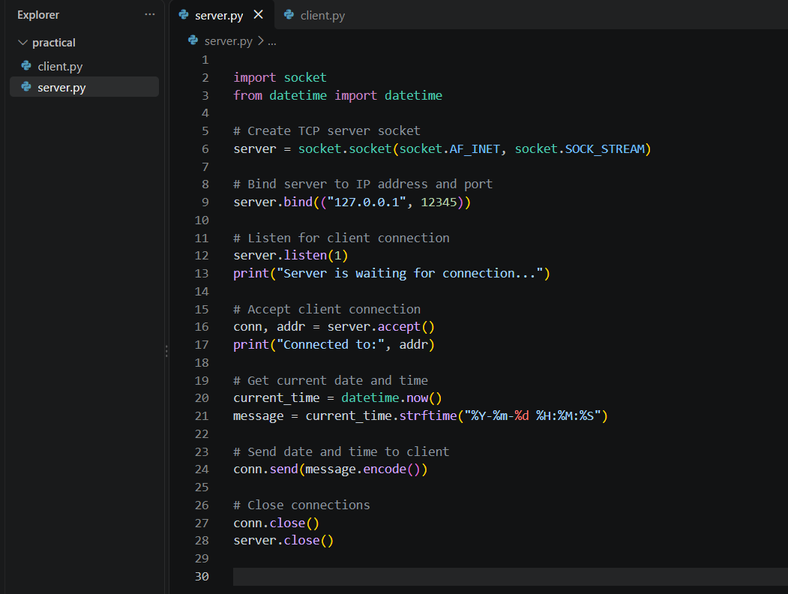
Client Program
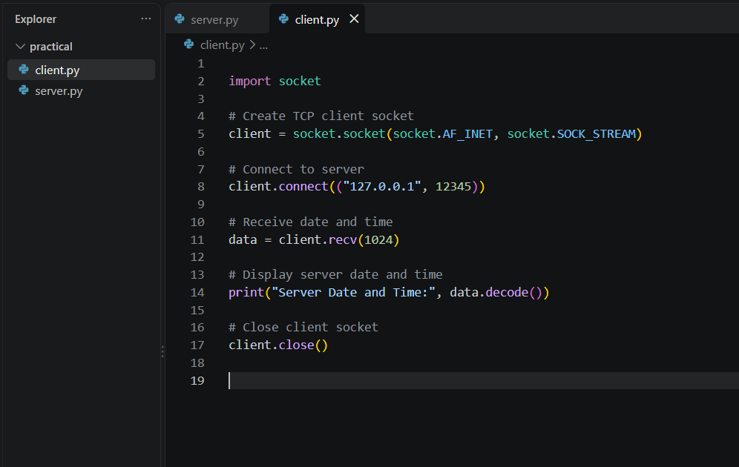

Server Output
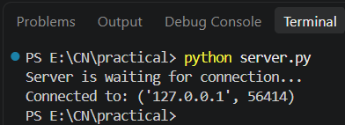

Client Output
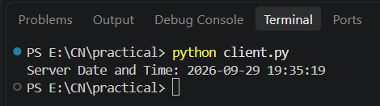

Result:
The TCP client-server program was successfully implemented in Python. The client connected to the server, received the server's current date and time, and displayed it on the terminal.
References:
1. https://www.netacad.com/courses/packet-tracer
2. https://skillsforall.com/course/getting-started-cisco-packet-tracer
3. https://www.geeksforgeeks.org/how-address-resolution-protocol-arp-works/
4. https://www.tutorialspoint.com/address-resolution-in-arp

